**Kubernetes**

Kubernetes - orchestration of docker containers , administering, clustering

swarm , kubernetes , openshift does same work but kubernnetes has lots of features and it is good among them.

**Docker Setup**:

sudo yum install -y yum-utils device-mapper-persistent-data lvm2

sudo yum-config-manager --add-repo https://download.docker.com/linux/centos/docker-ce.repo

wget http://mirror.centos.org/centos/7/extras/x86_64/Packages/pigz-2.3.3-1.el7.centos.x86_64.rpm

wget http://mirror.centos.org/centos/7/extras/x86_64/Packages/container-selinux-2.55-1.el7.noarch.rpm

yum install -y docker-ce

**kubernetes setup**:

cat <<EOF > /etc/yum.repos.d/kubernetes.repo

[kubernetes]

name=Kubernetes

baseurl=https://packages.cloud.google.com/yum/repos/kubernetes-el7-x86_64

enabled=1

gpgcheck=1

repo_gpgcheck=1

gpgkey=https://packages.cloud.google.com/yum/doc/yum-key.gpg https://packages.cloud.google.com/yum/doc/rpm-package-key.gpg

EOF

setenforce 0

yum install -y kubelet kubeadm kubectl

systemctl enable kubelet && systemctl start kubelet

Note: Docker and Kubelet should be in same cgroup

docker info | grep cgroup

sed -i 's#Environment="KUBELET_CGROUP_ARGS=--cgroup-driver=systemd"#Environment="KUBELET_CGROUP_ARGS=--cgroup-driver=cgroupfs"#g' kubelet.service.d/10-kubeadm.conf

kubeadm join 172.31.31.108:6443 --token n5vglu.dzzgfrjqgmasu76t --discovery-token-ca-cert-hash sha256:6b37225b6aecc91f41dc70992e8f0fadadf67dc6ebfee8a7da858637d584c220

**--feature-gates=SelfHosting=true**

kubectl taint nodes --all node-role.kubernetes.io/master-

**for easy installation**:

git clone <https://github.com/wardviaene/on-prem-or-cloud-agnostic-kubernetes.git>

master: install-kubernetes.sh

node: install-node.sh

creating user: create-user.sh

Restarting Master:

for SERVICES in etcd kube-apiserver kube-controller-manager kube-scheduler flanneld; do

systemctl restart $SERVICES

systemctl enable $SERVICES

systemctl status $SERVICES

done

**restart kubelet/node services**

for SERVICES in kube-proxy kubelet flanneld docker; do

systemctl restart $SERVICES

systemctl enable $SERVICES

systemctl status $SERVICES

done

running app on k8s:

we need to create a pod definition first

pod = service,instance of dock image

pod describes an app running on k8s

pod can contain 1 or more tightly coupled containers

containers inside pod can talk to each other with their local ports

we need to write pod.yml file

kubectl create -f pod.yml

kubectl get pod

kubectl describe pod <pod name>

kubectl expose pod <pod name> --port=<port no> --name=<service name>

kubectl port-forward <pod name> <port number>

kubectl attach <pod name> -i

kubectl exec <pod name> -- command

kubectl label pod <pod name> mylabel=<name>

kubectl run -i --tty busybox --image=busybox --restart=never -- sh

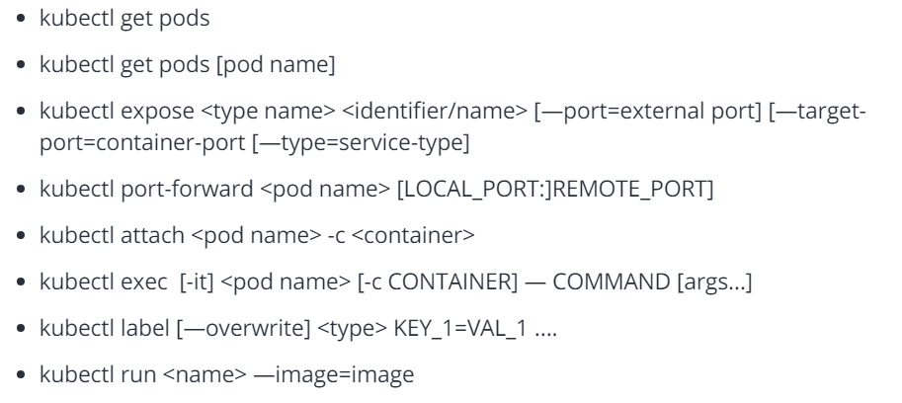

Install Minikube for practicing and learning:

Minikube local cluster on single node for practicing

https://storage.googleapis.com/minikube/releases/latest/minikube-windows-amd64.exe

install virtual box before using minikube.(it is required to run minikube)

minkube start - for starting local kub cluster on single host for learning and development purpose(not recommended for production)

we experiment with kubectl command once the cluster is started

**Deployments**:

they are group services which define applications.

deployments are types of resources and there references.

deploy are typically described in yaml format.

Deployments are simple - types of containers required for apps and how they are interconnected to each other and health checks of those services.

key tasks for deployment:

1 - define the deployment

2 - expose the services to world

3 - deploy it to kub cluster

**Architecture overview**:

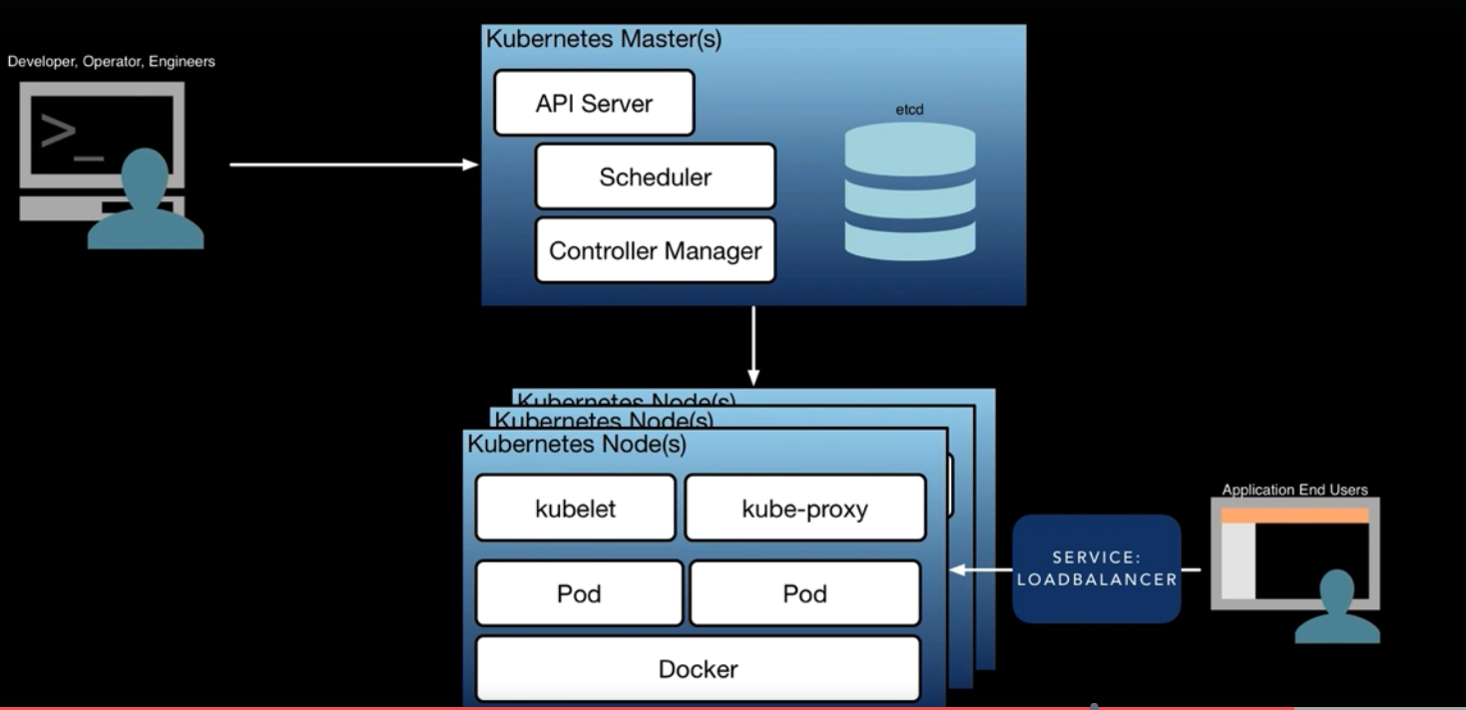

Master - place for administering containers/pods on nodes.

Nodes - VM or physical server where pods/services are running

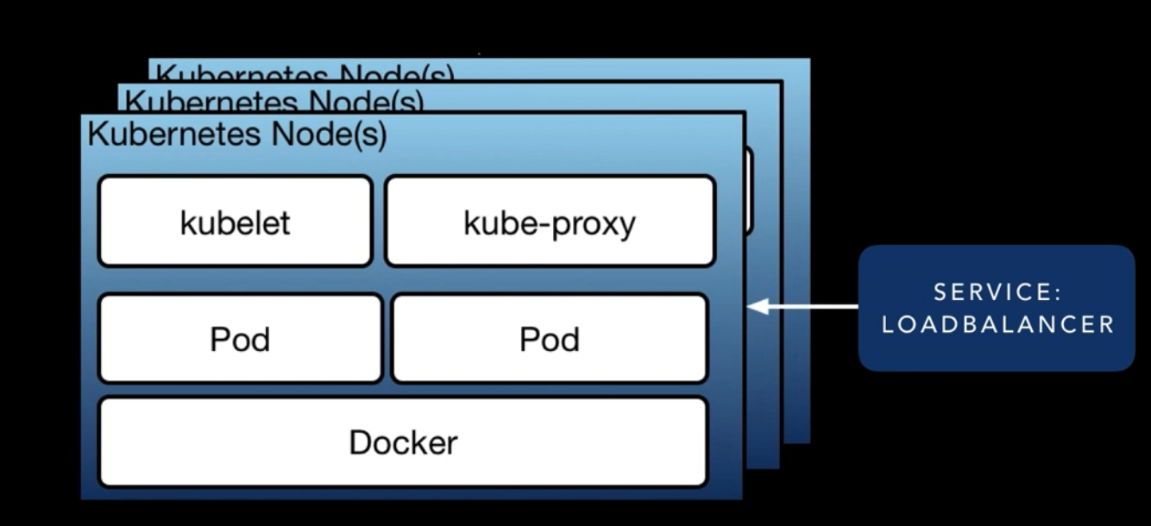

It is managed by manager

There can be any number of nodes tagged to a master based on our requirement

Master decide where to run the pod(scheduler).

Kubelet – node agent for node.

Kubeproxy deals with networking.

Pods are exposed to external ip and external port using service LB.

**Scaling & Replication** :

Can handle both stateful & stateless applications.

Stateless are highly recommended.

Predominant way is to define replica details in deployment.yaml

Kubectl scale –replicas=4 deployment/<name>

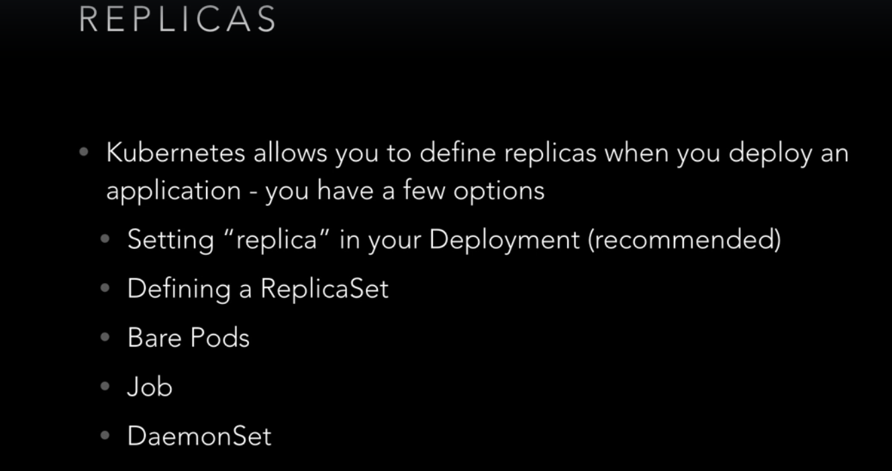

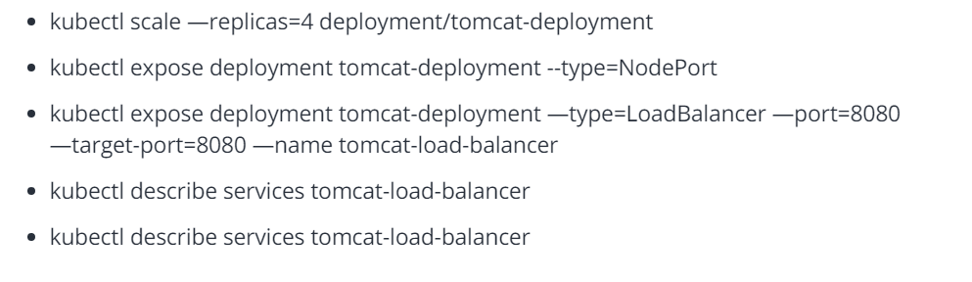

**Deploying to kubernetes**:

kubectl rollout status deployment tomcat-deployment

kubectl set image deployment/tomcat-deployment tomcat=tomcat:9.0.1

kubectl rollout history deployment/tomcat-deployment --revision=2

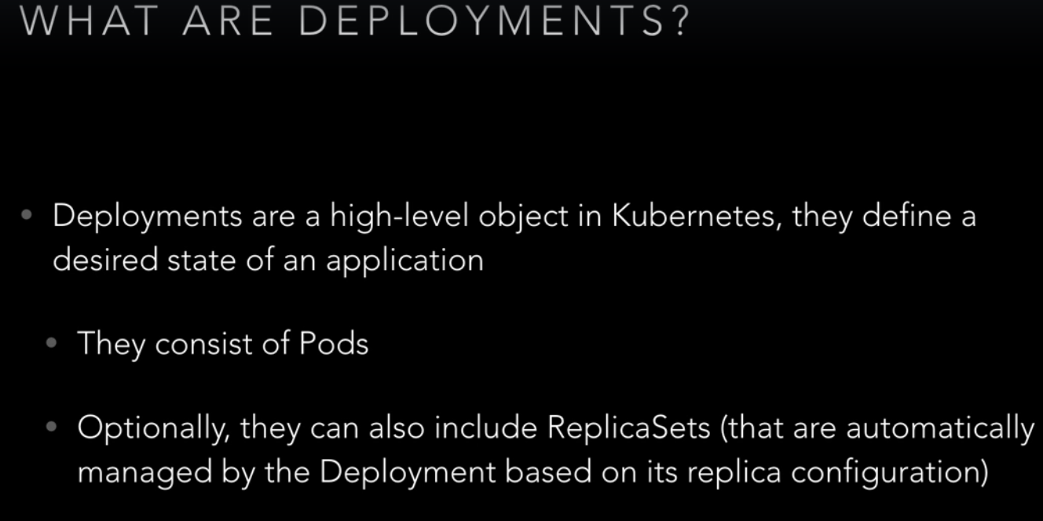

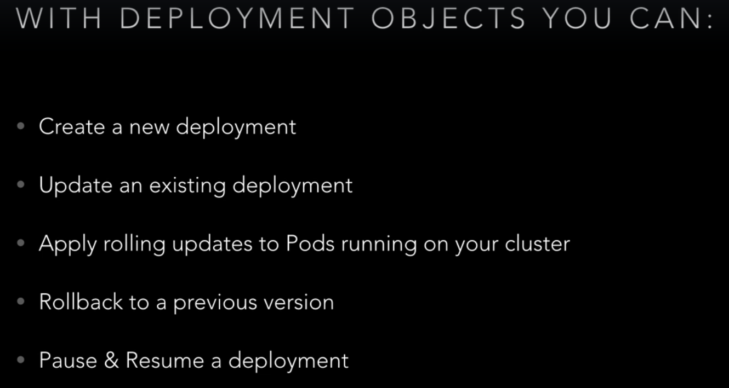

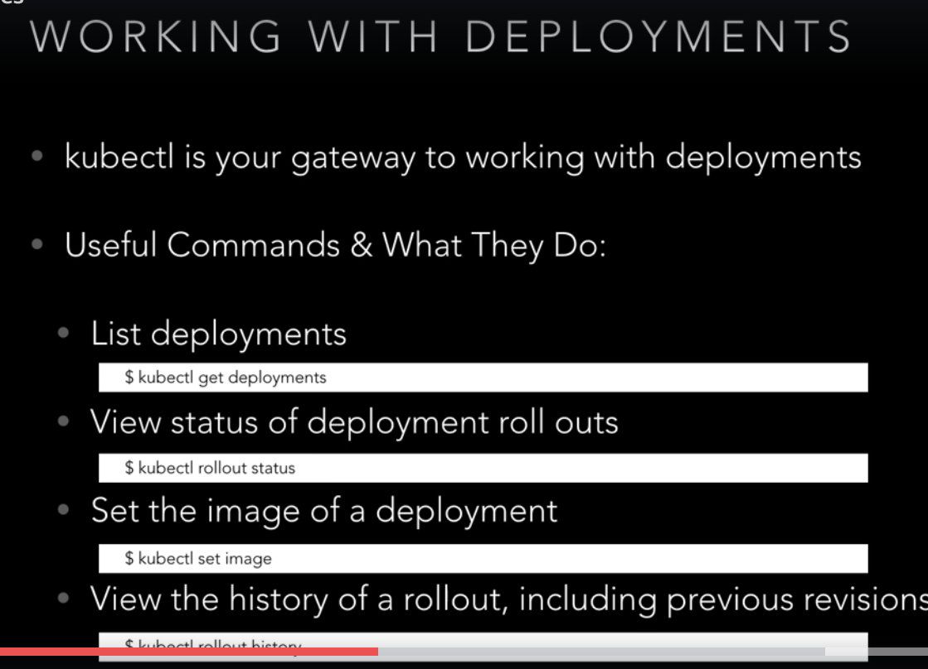

**Label & Selectors**:

Kubectl get nodes

Kubectl label node <node name> storageType=SSD

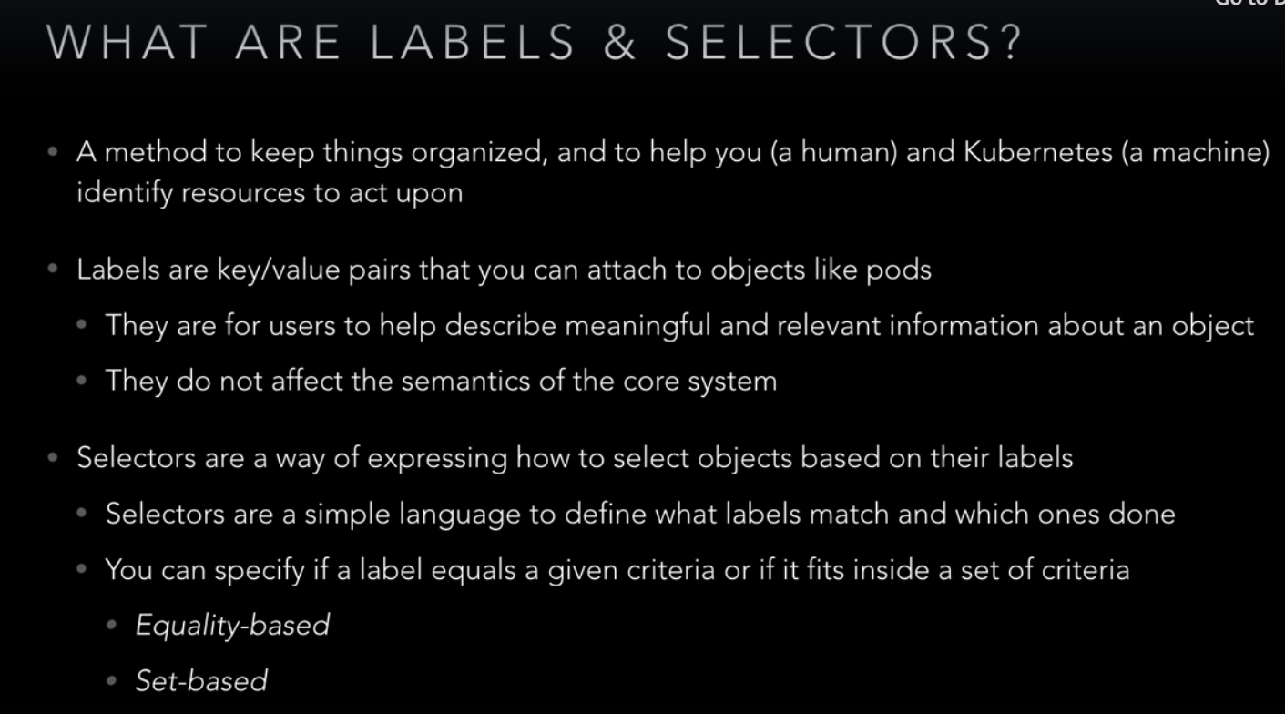

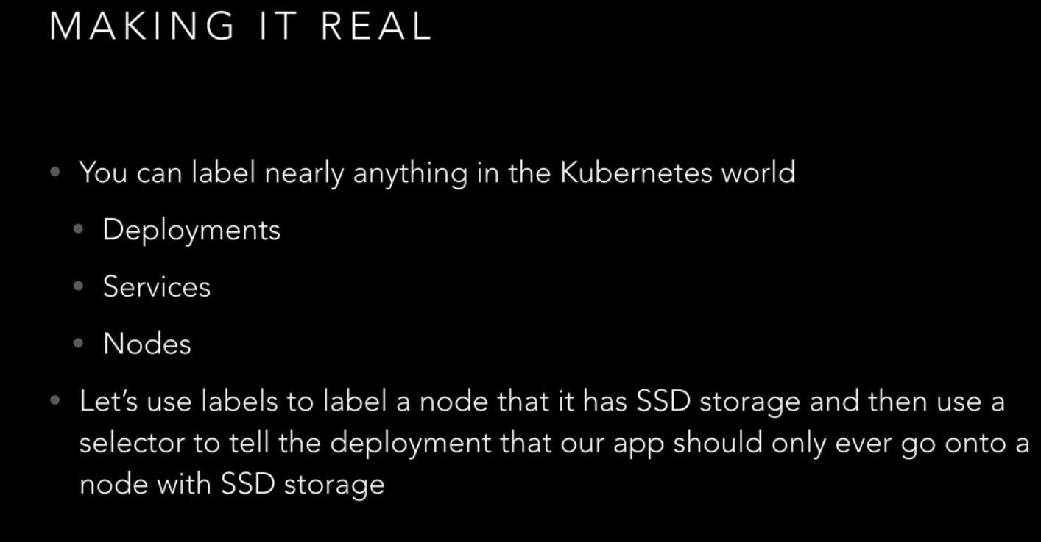

**Health Checking**:

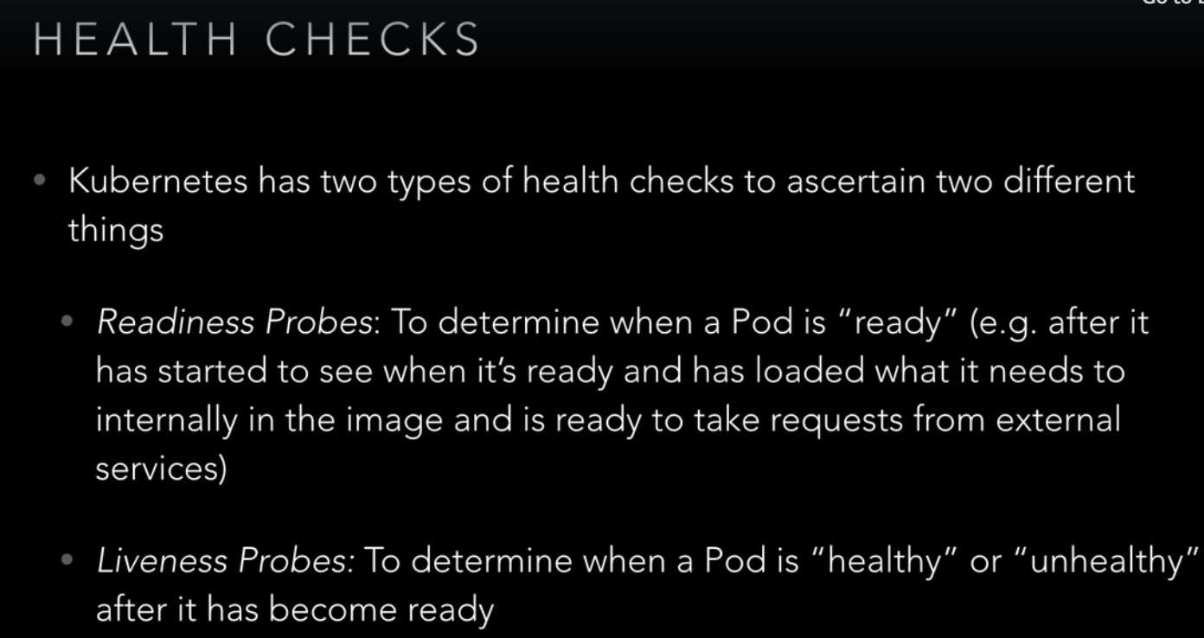

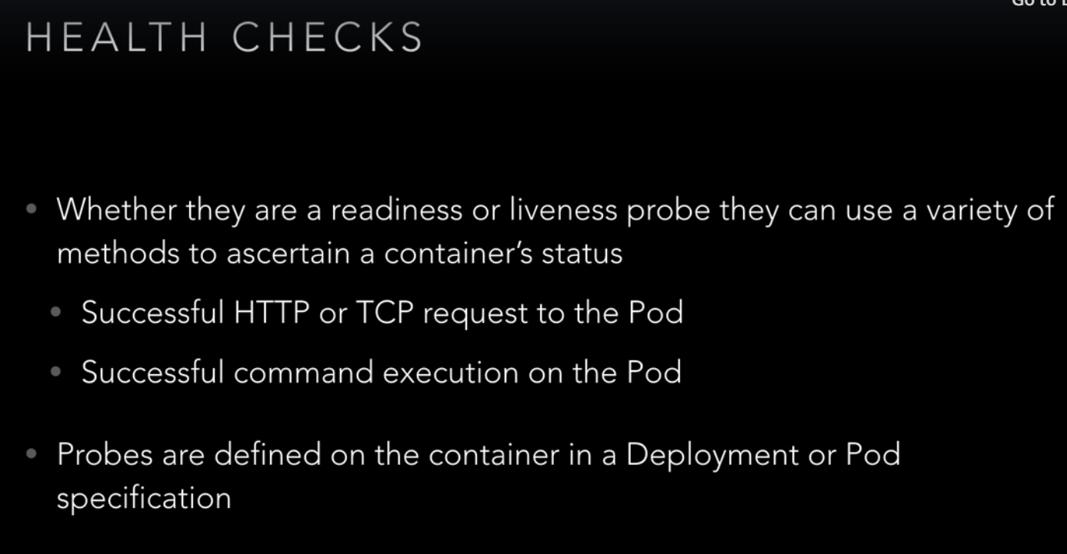

**Web Interface**:

* kubectl proxy
* kubectl create -f https://raw.githubusercontent.com/kubernetes/dashboard/master/src/deploy/recommended/kubernetes-dashboard.yaml

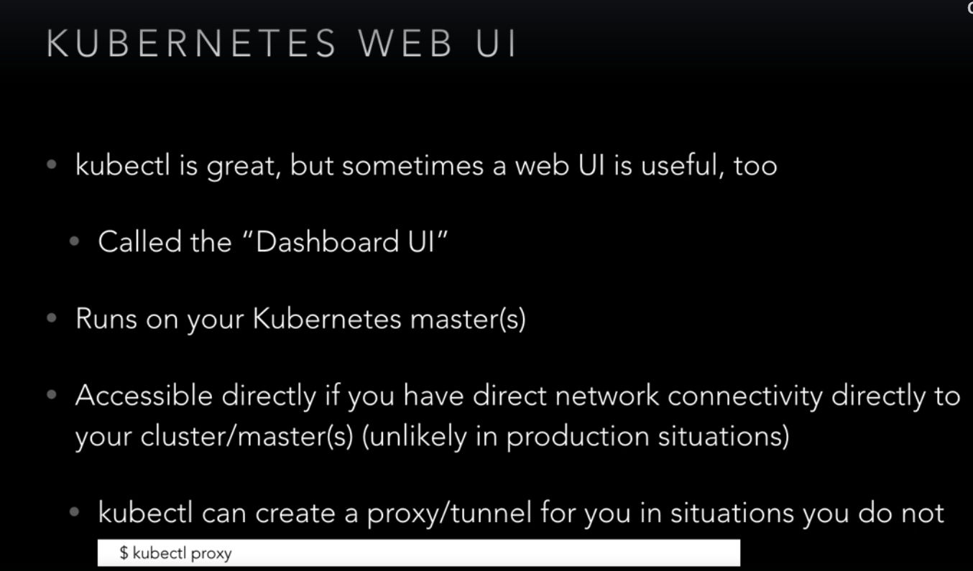

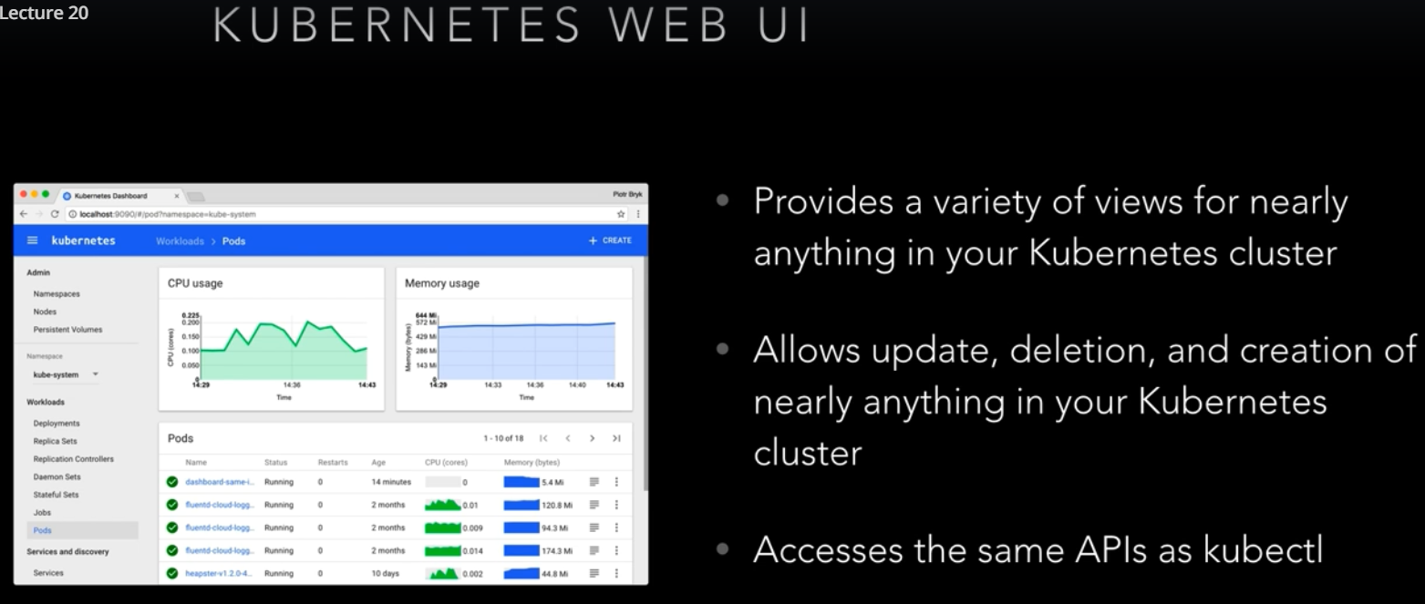

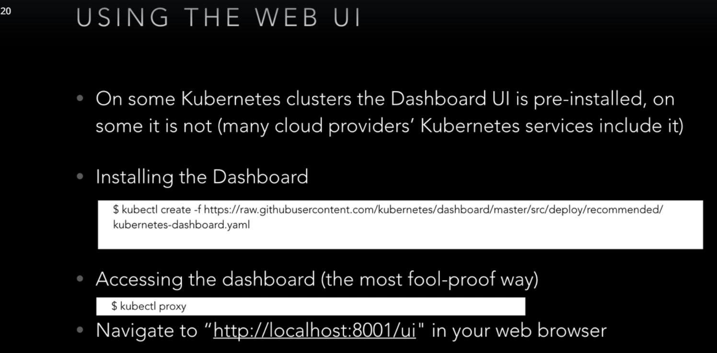

nohup kubectl proxy --port=80 --address=0.0.0.0 --accept-hosts=^.*$ > db.log &

How to login to UI

<https://github.com/kubernetes/dashboard/wiki/Creating-sample-user>

<https://github.com/kubernetes/dashboard/wiki/Accessing-Dashboard---1.7.X-and-above>

**DNS & Service Discovery**:

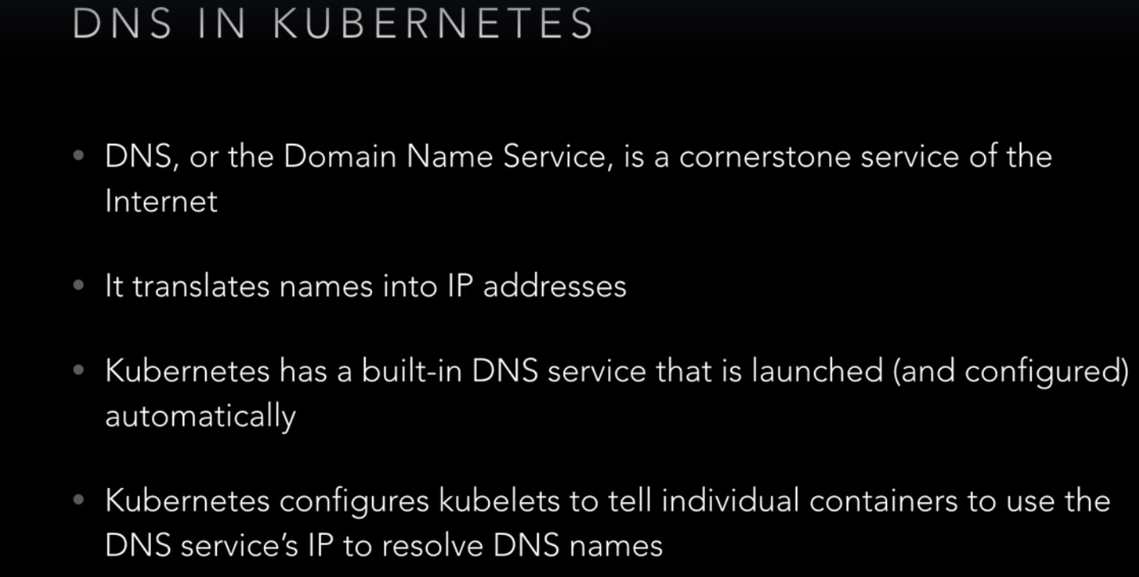

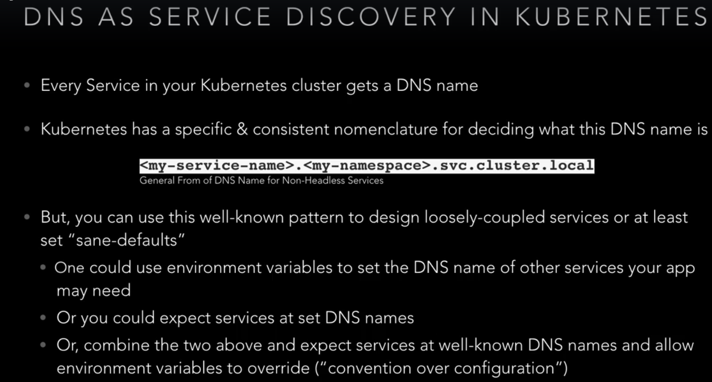

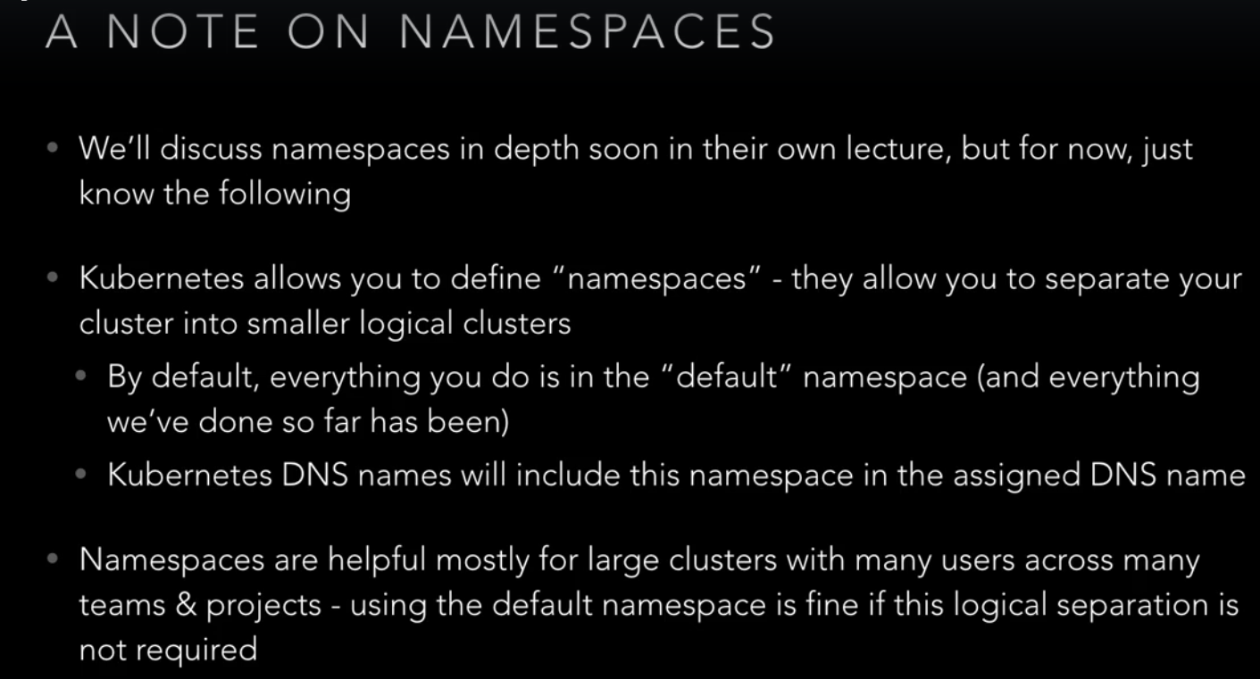

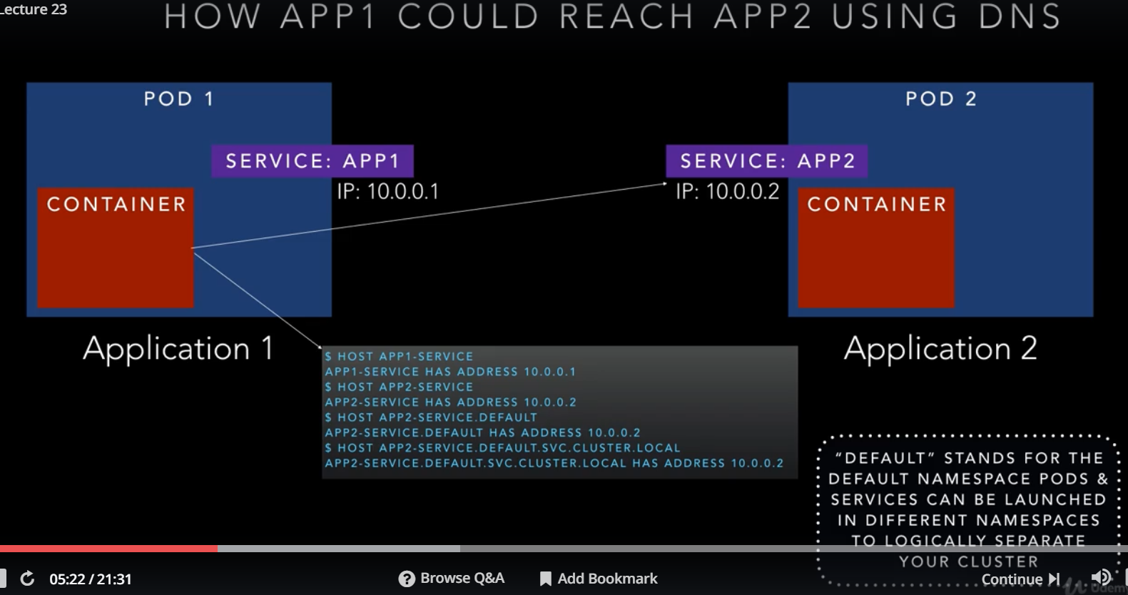

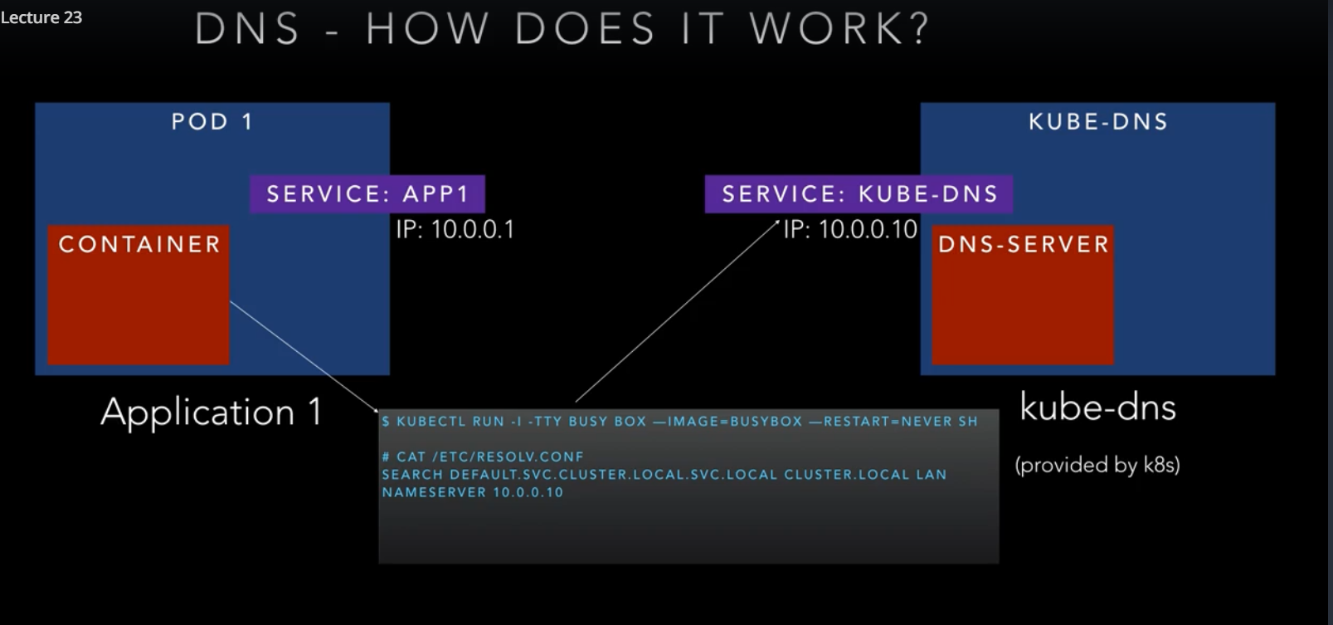

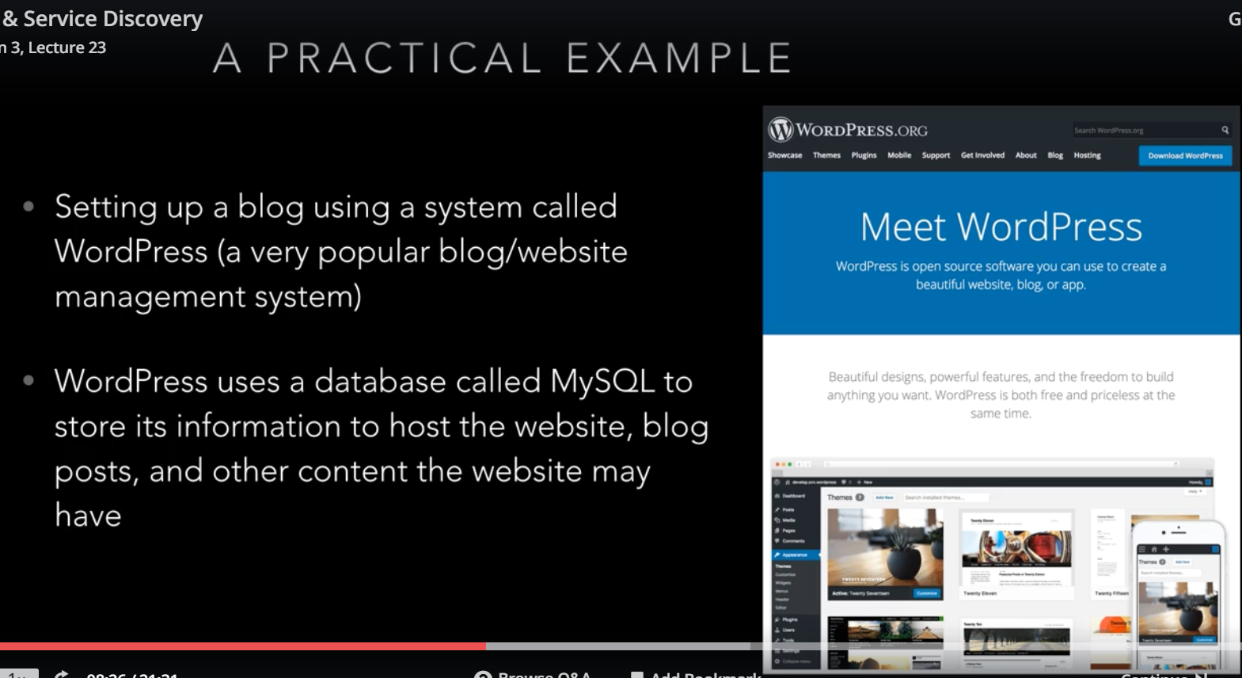

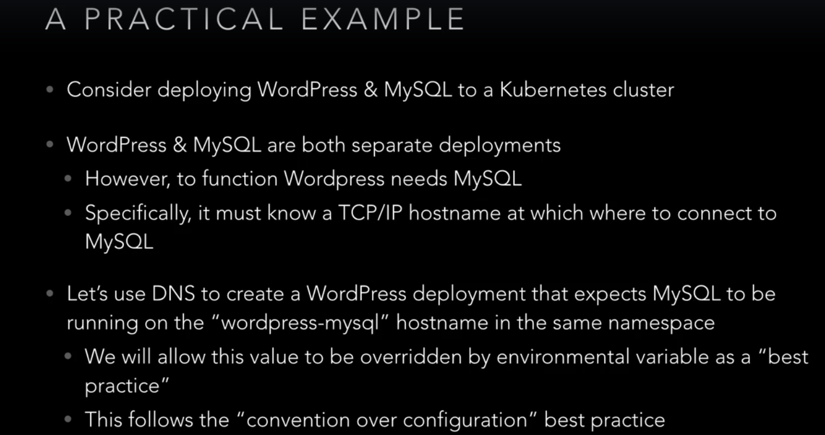

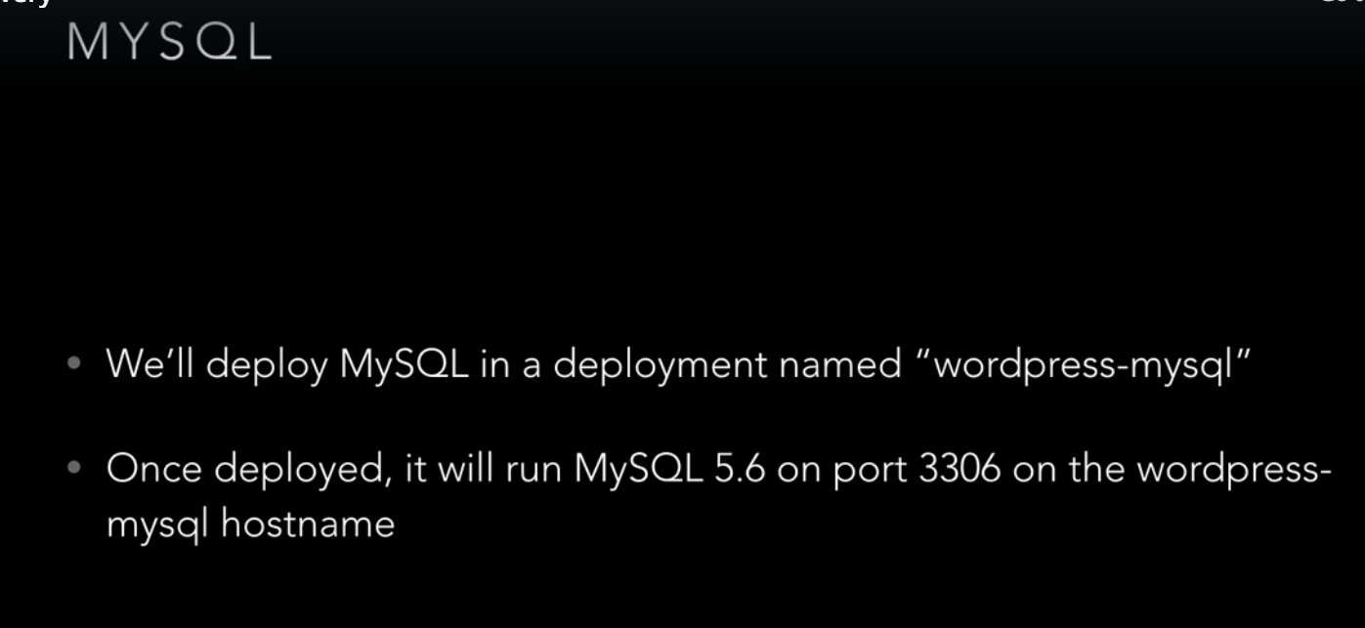

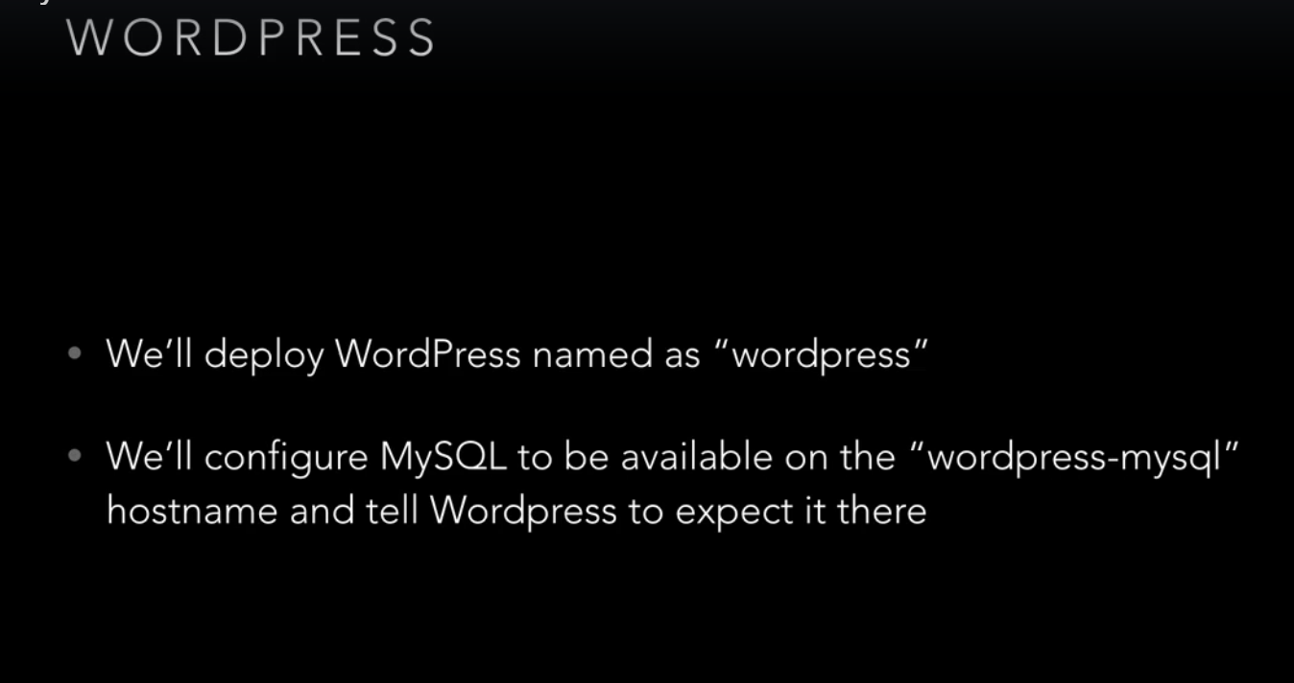

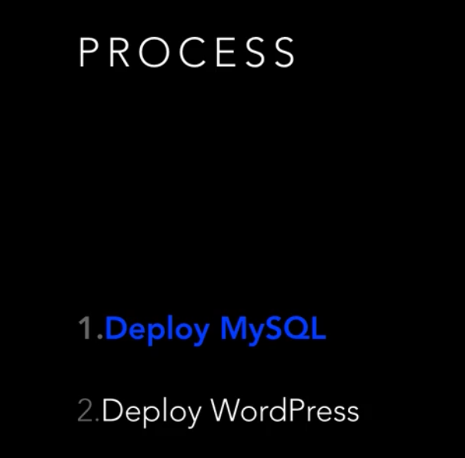

**Volumes**:

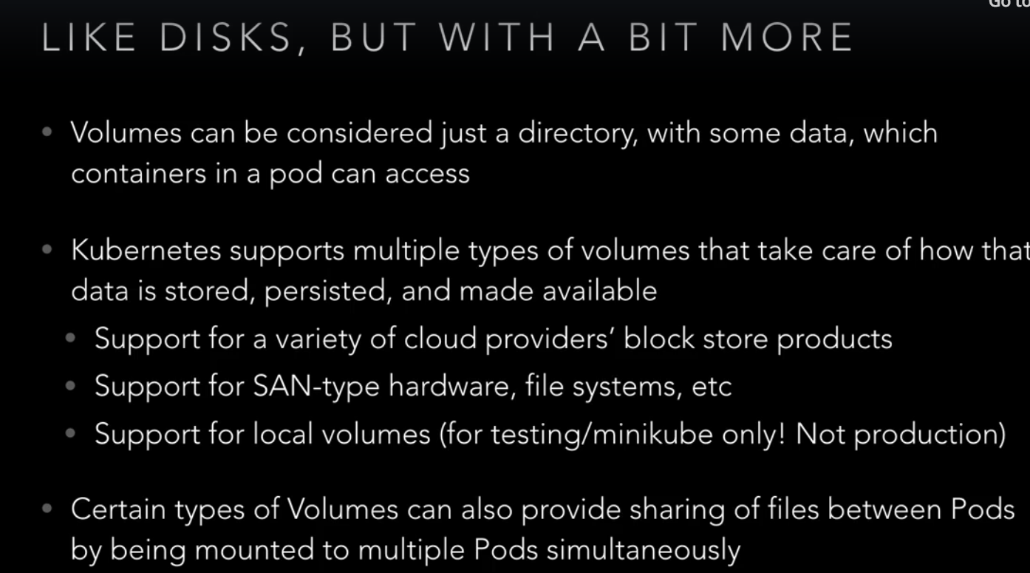

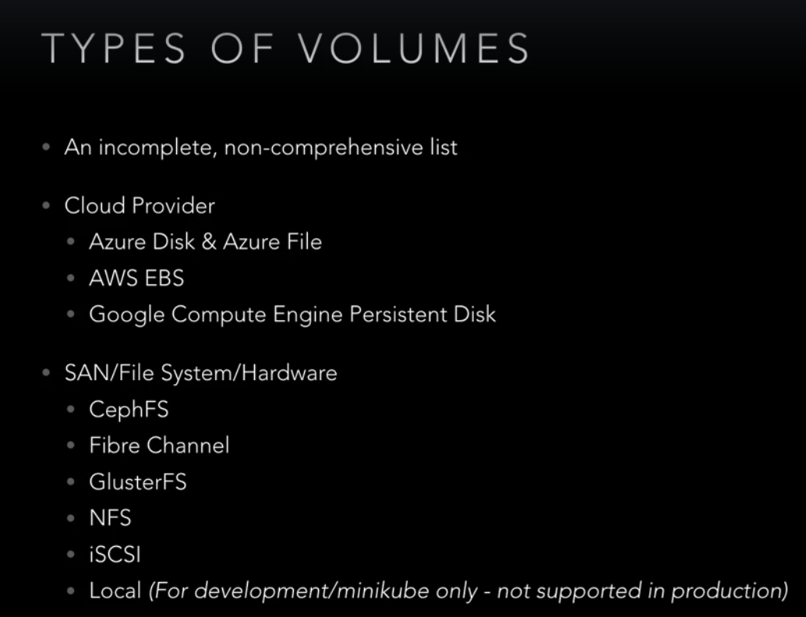

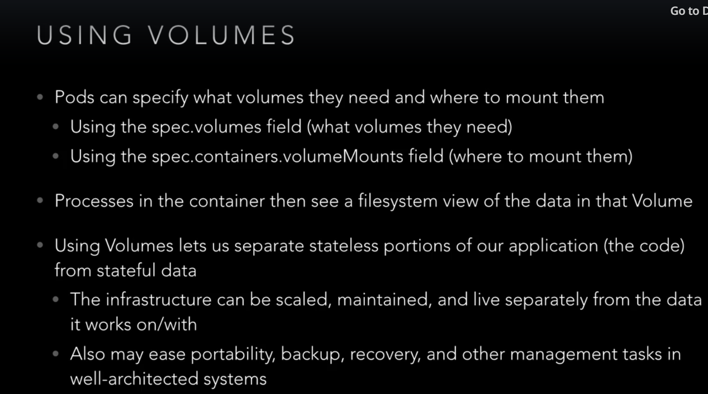

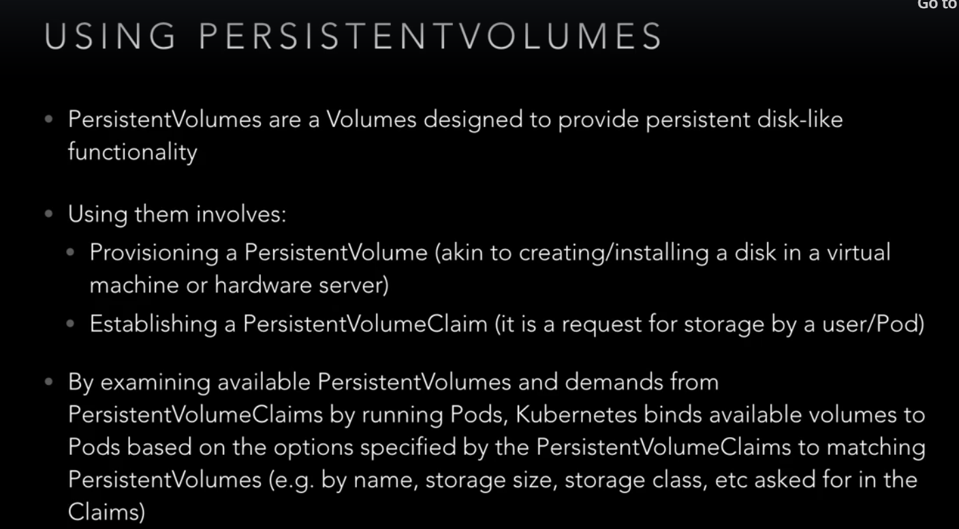

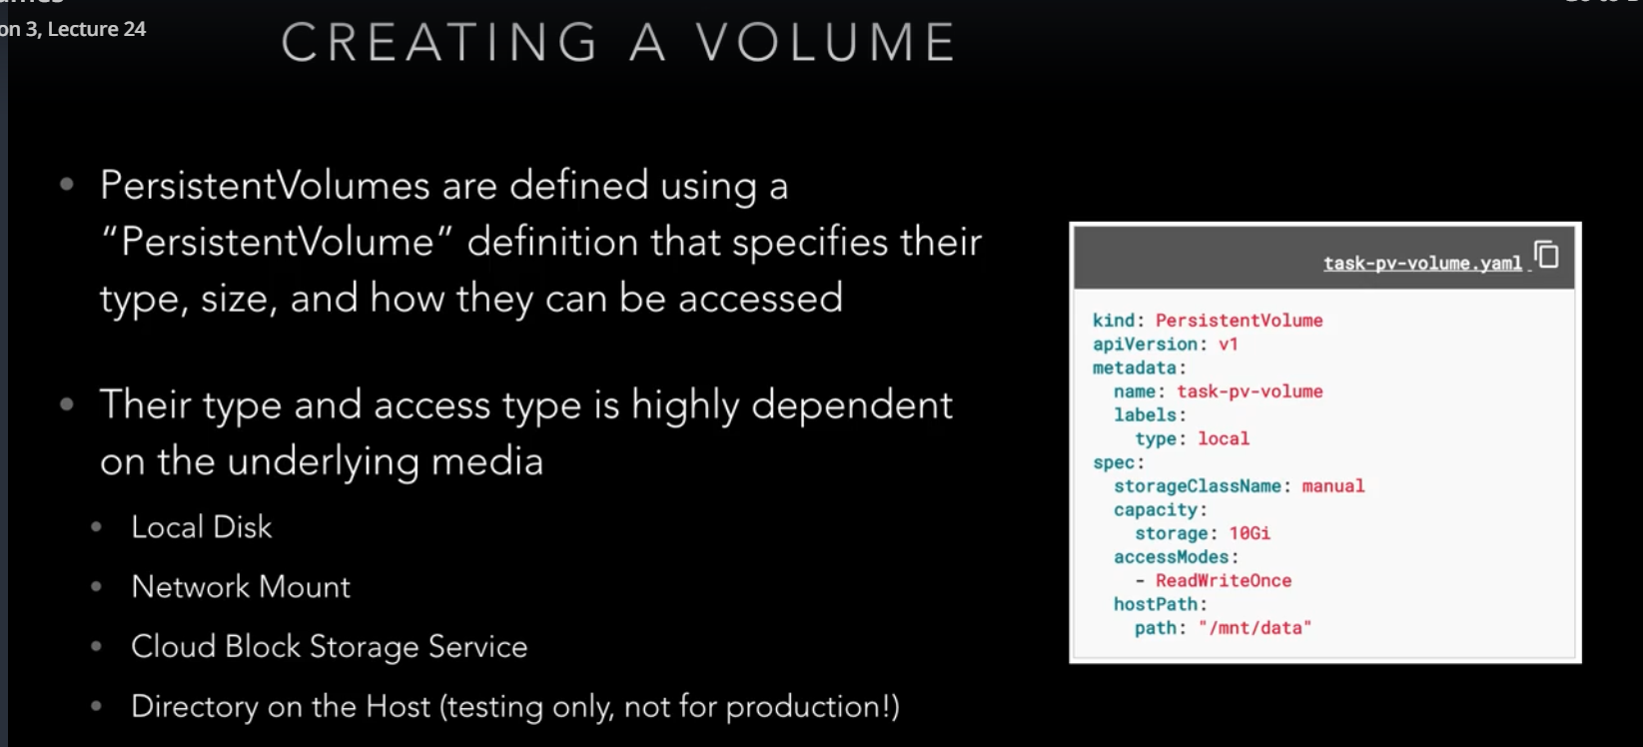

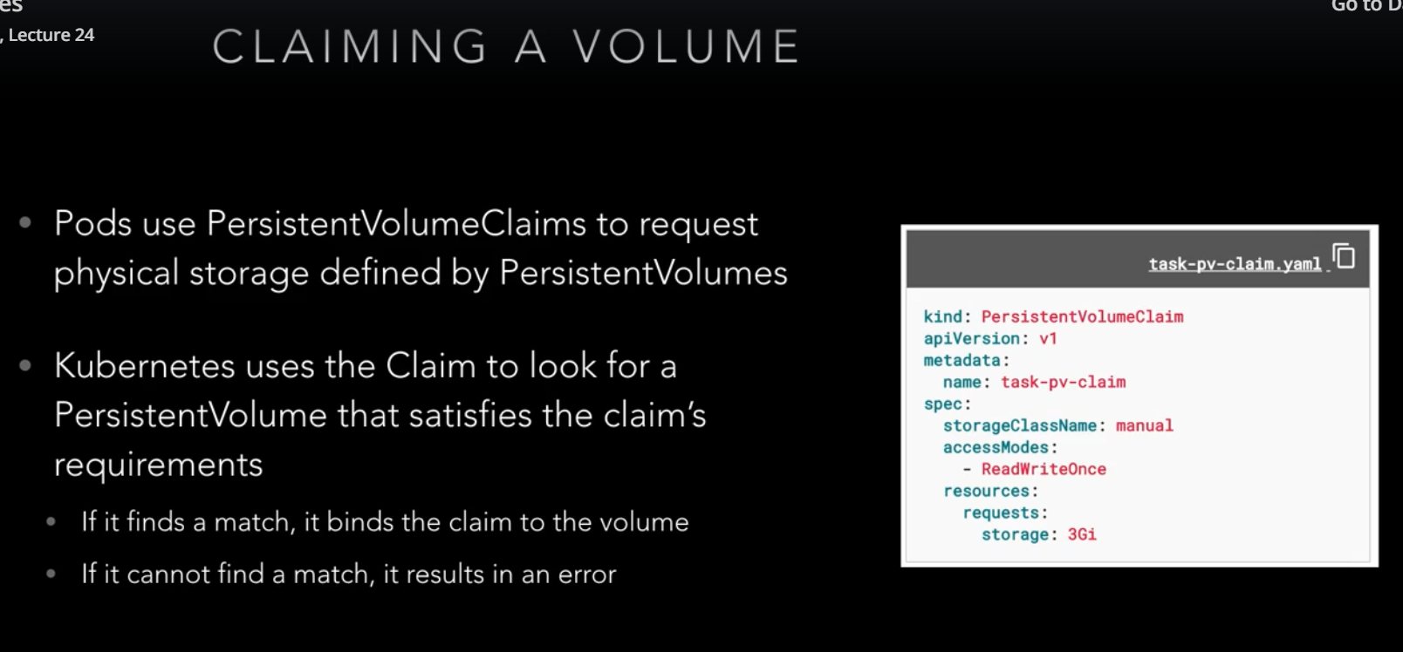

**Secrets**:

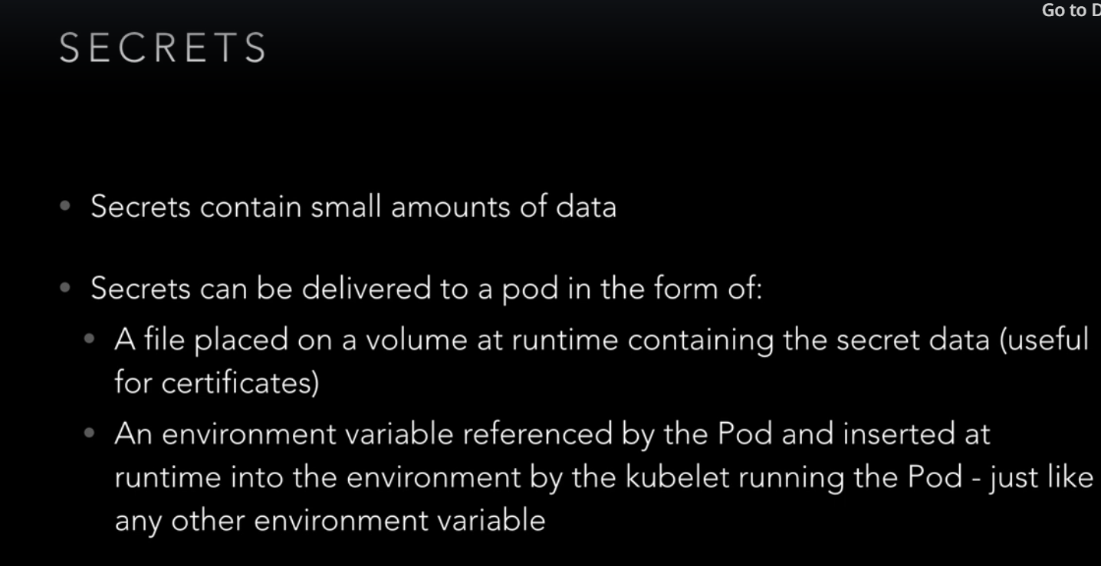

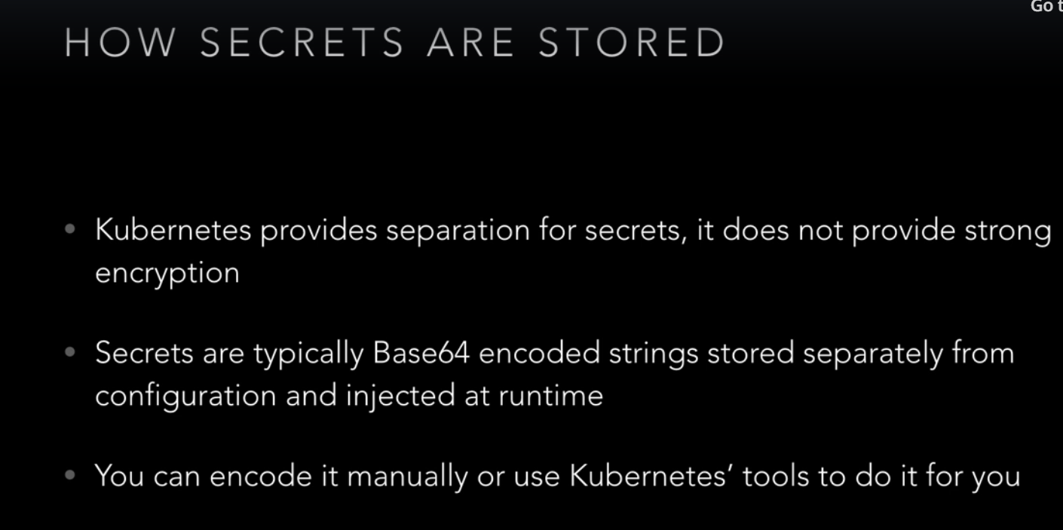

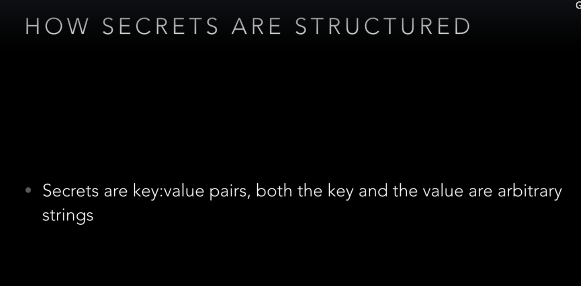

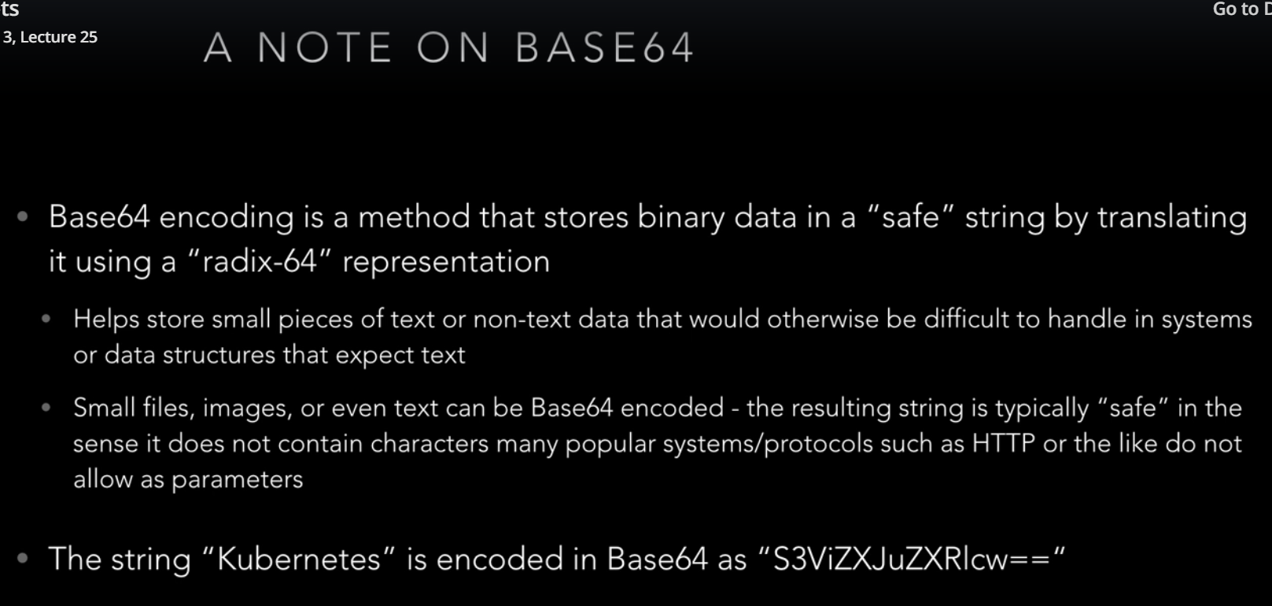

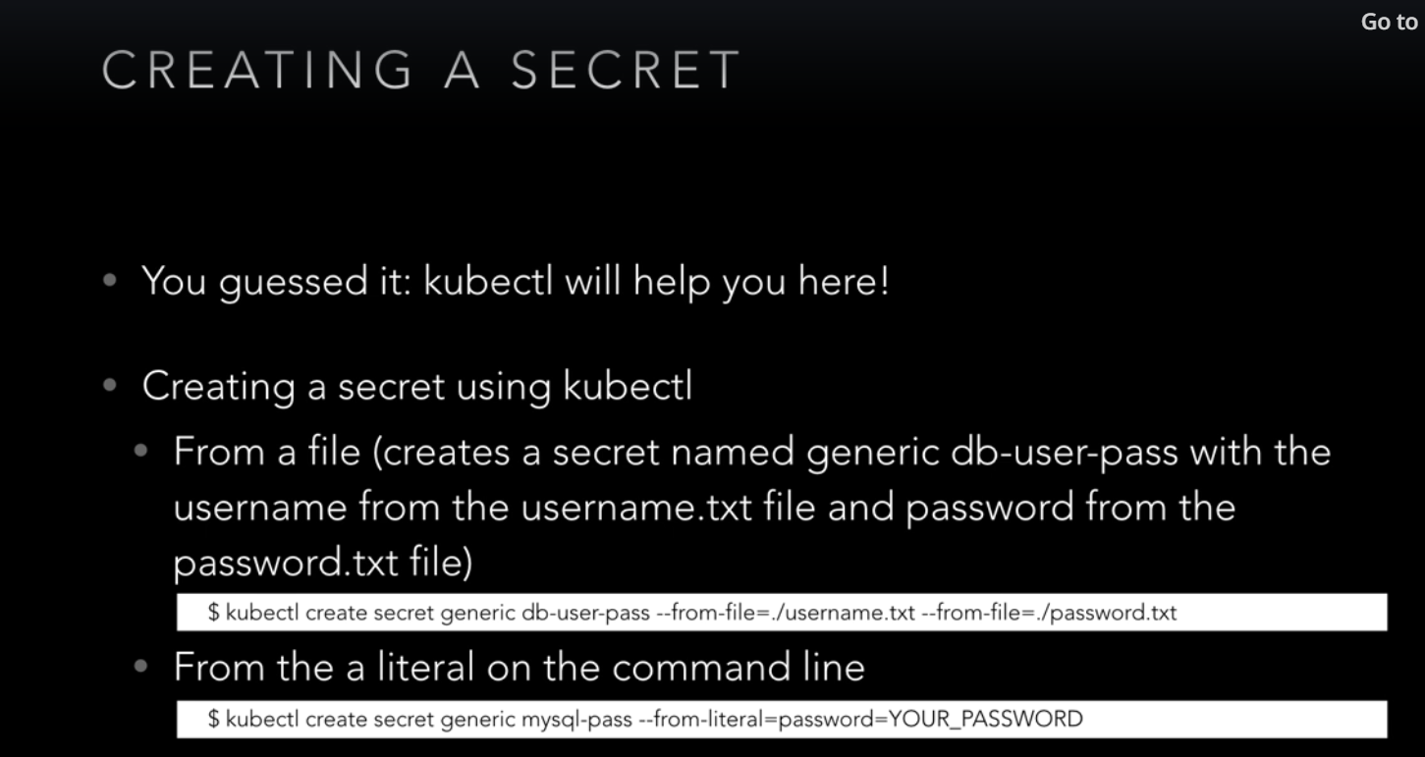

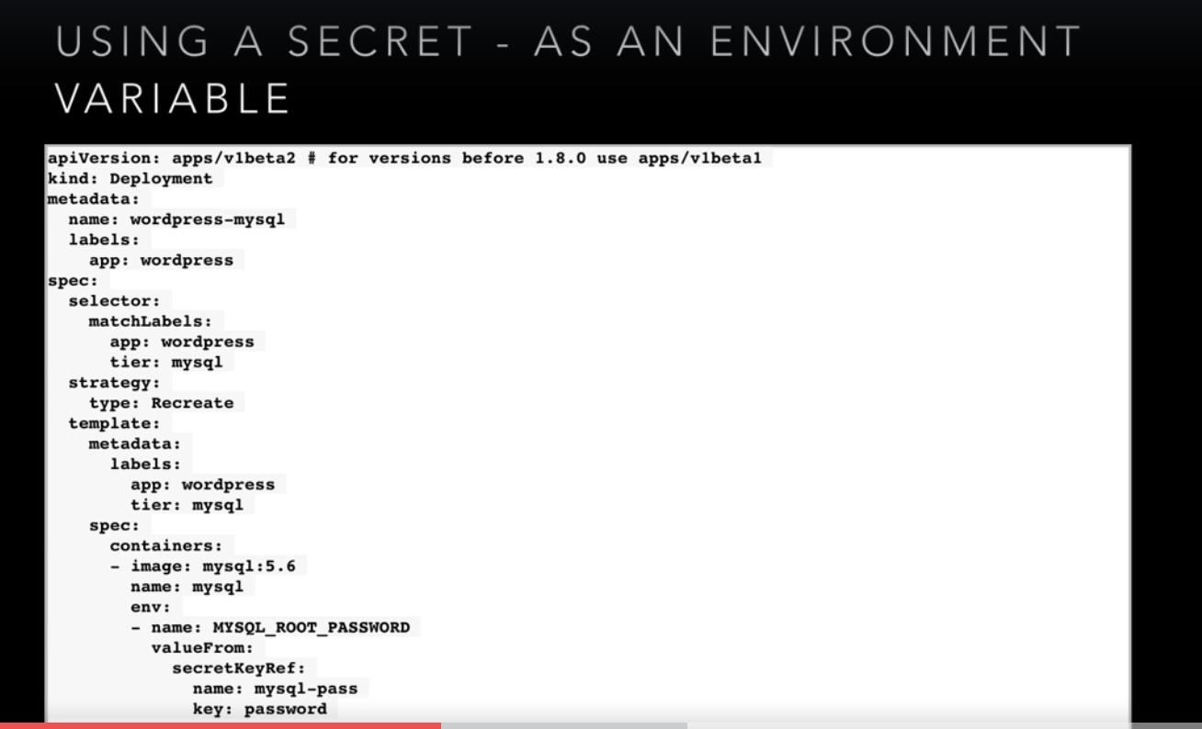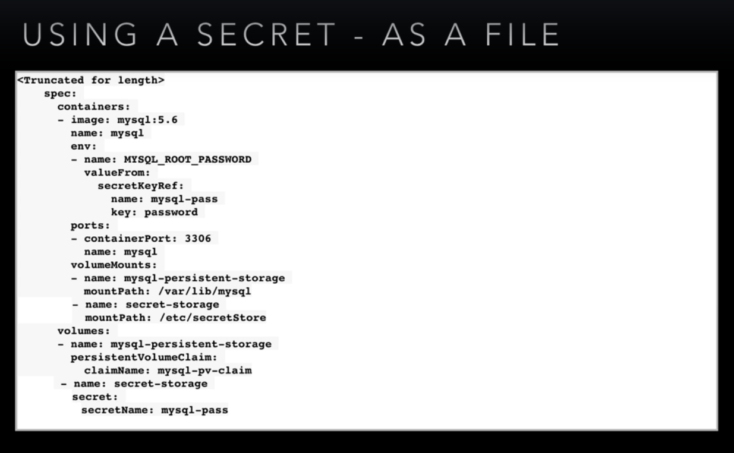  
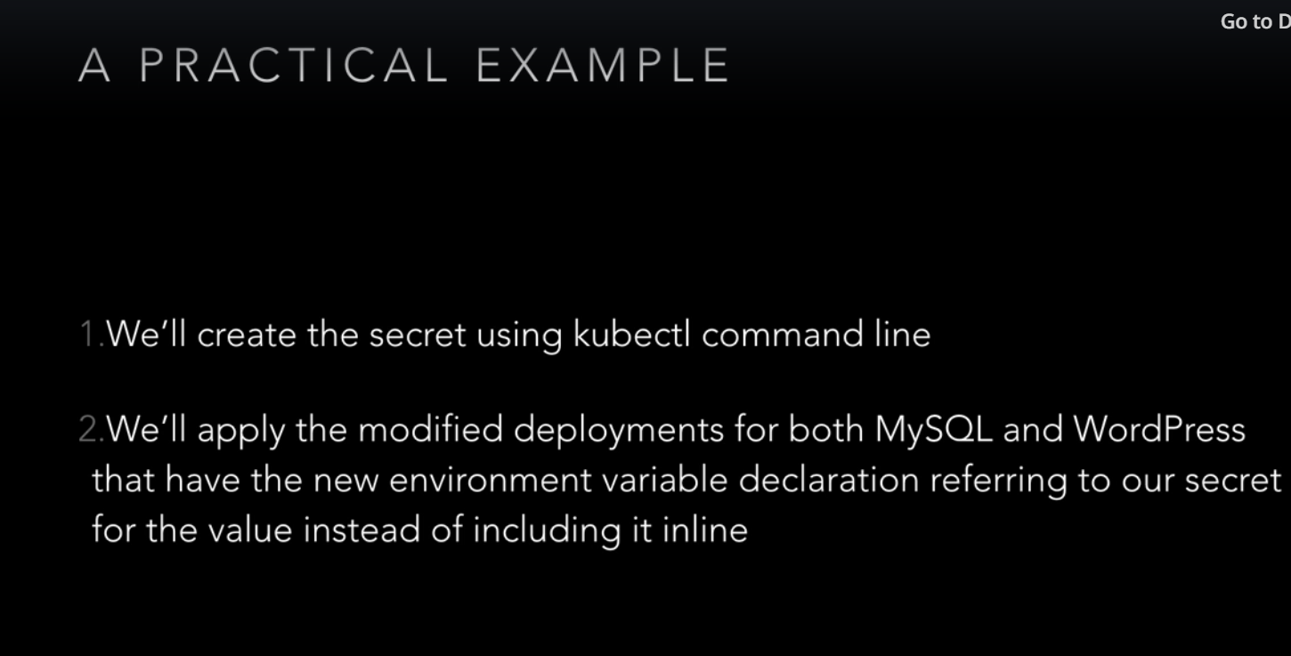

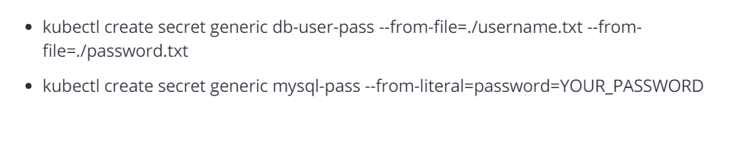

**Usage & Resource Monitoring**:

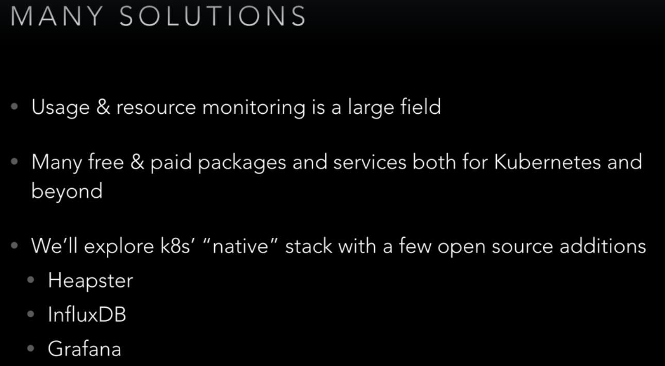

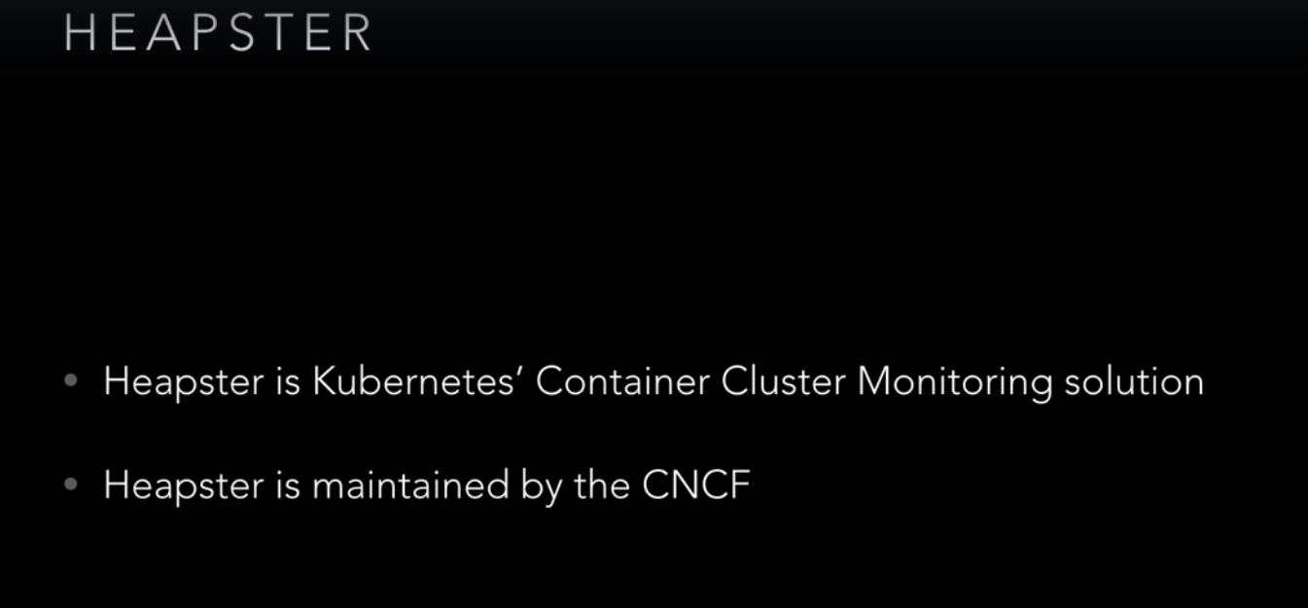

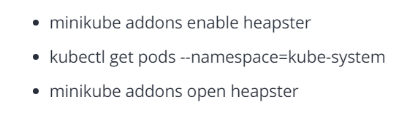

**Namespaces**:

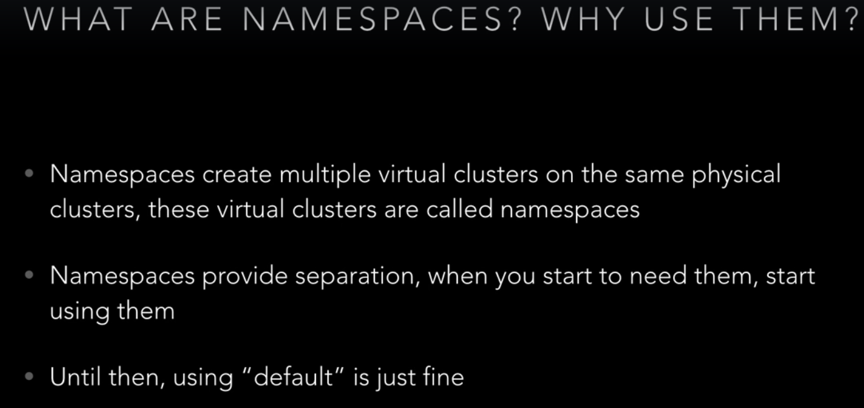

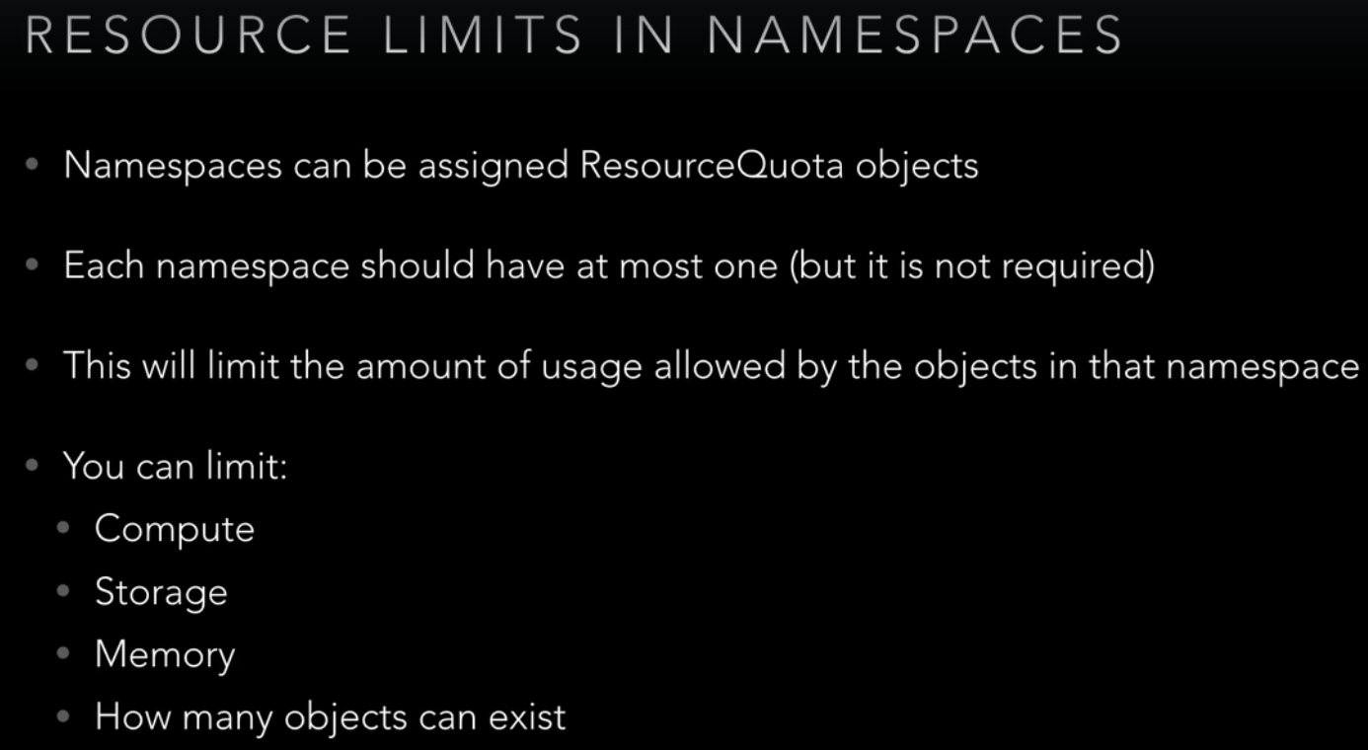

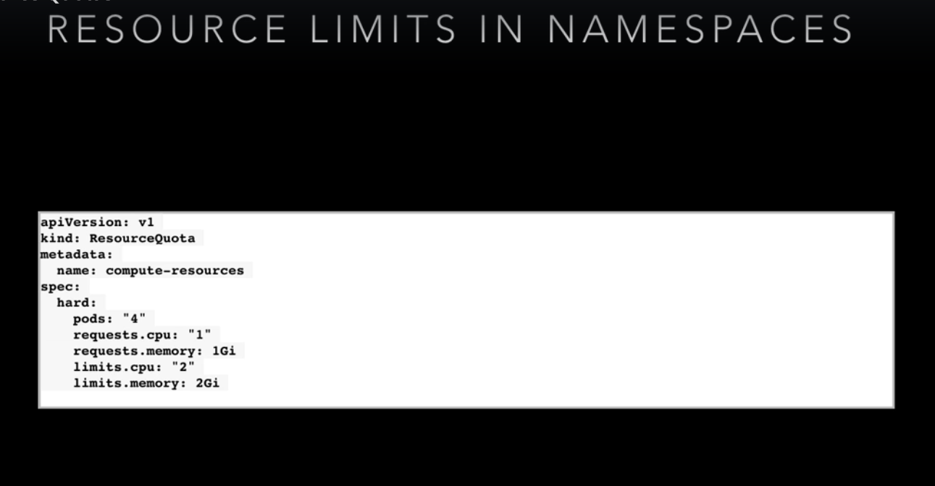

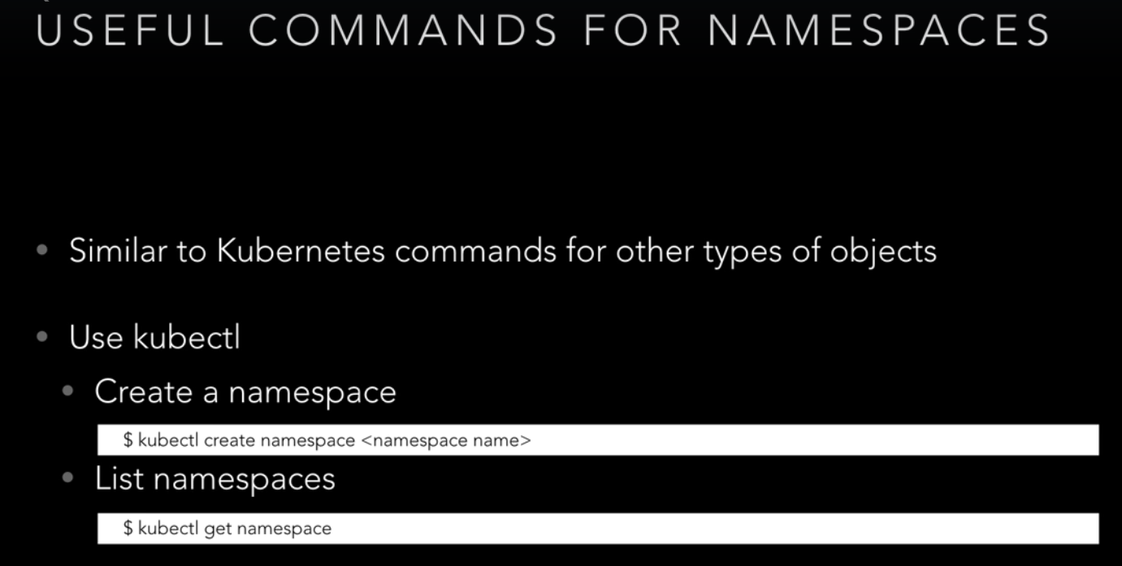

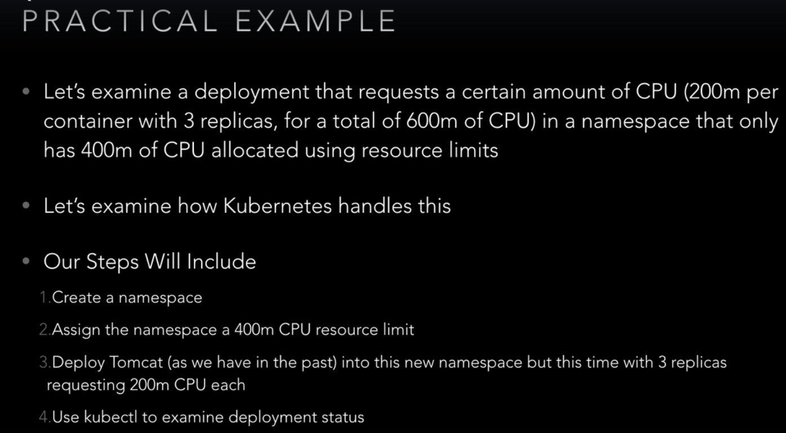

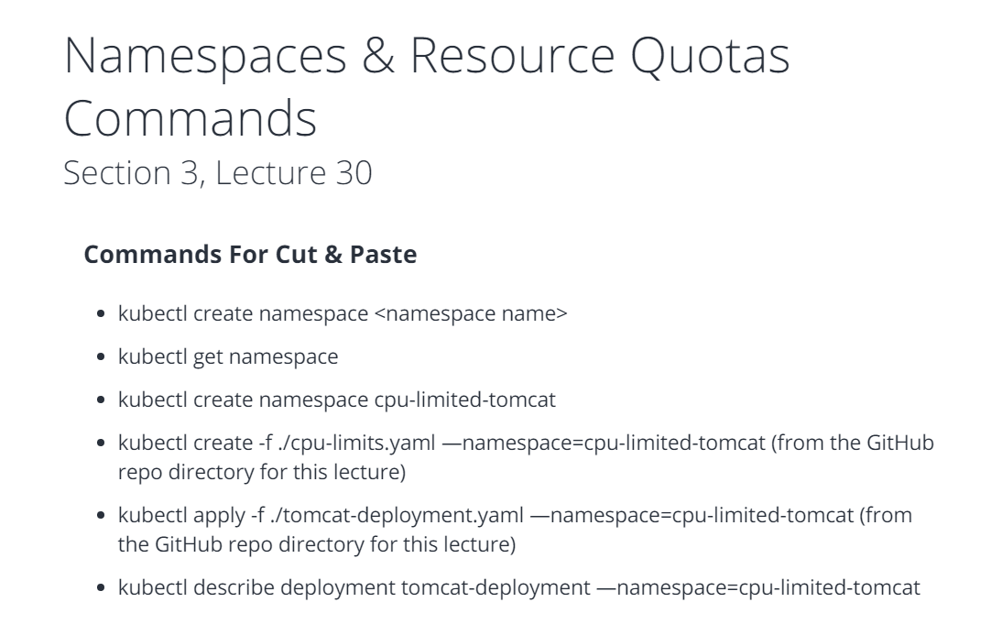

**Auto Scaling**:

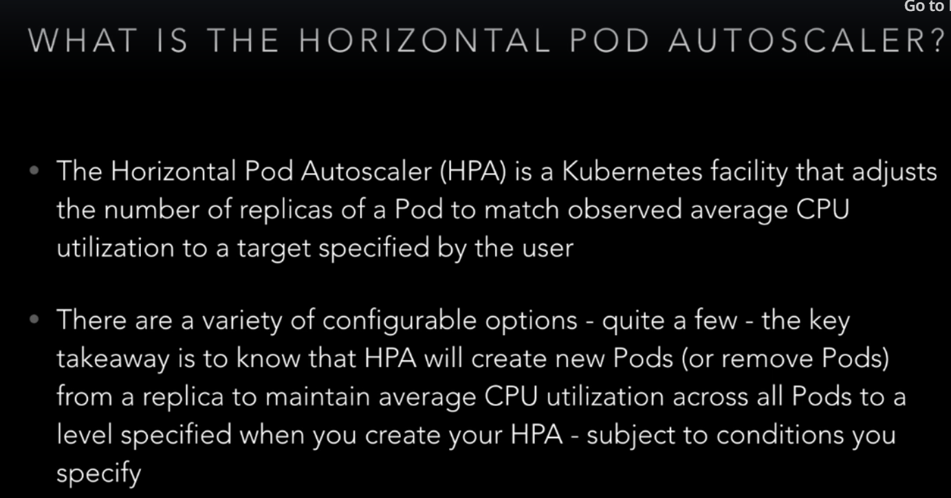

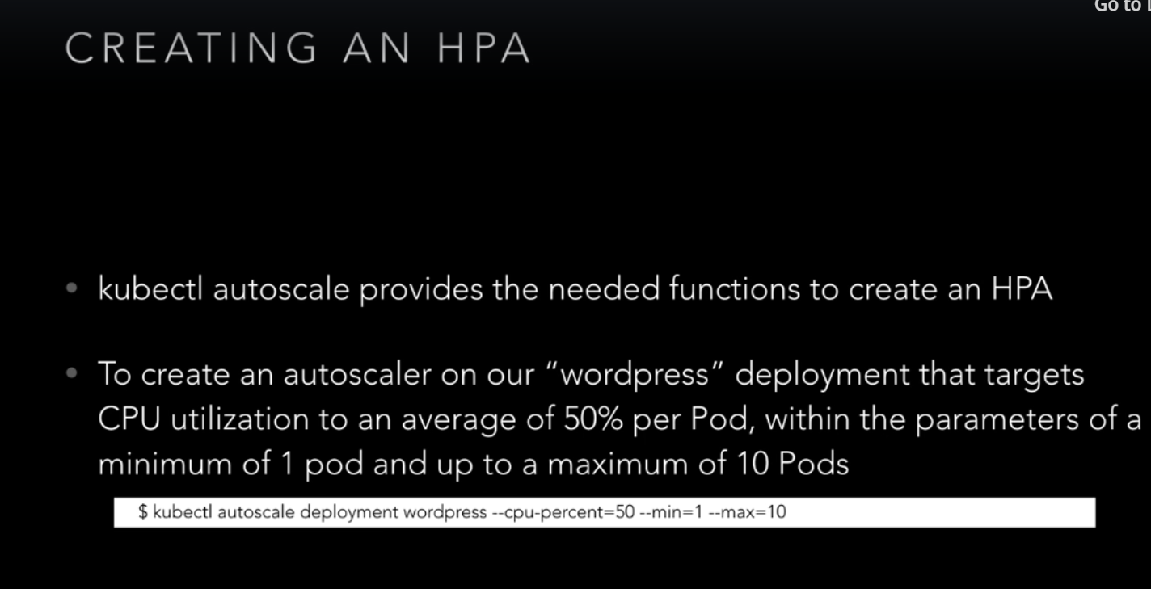

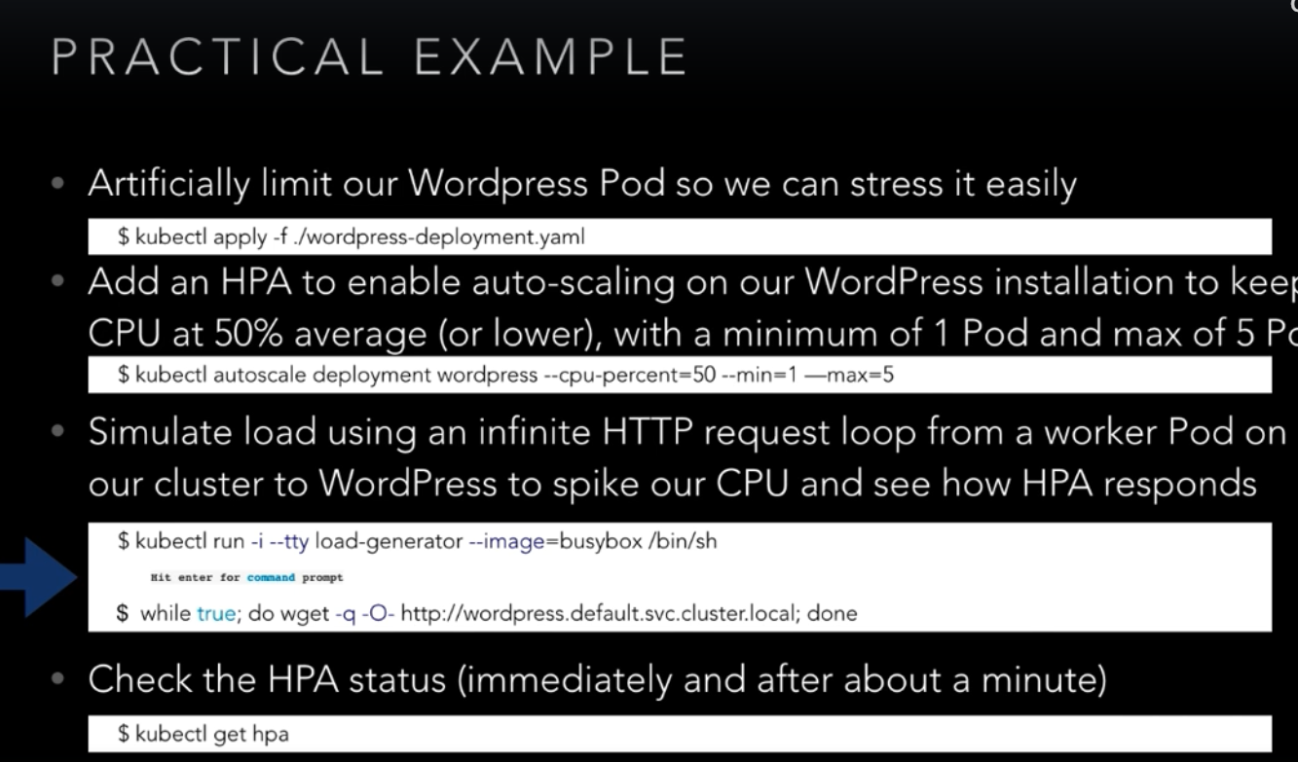

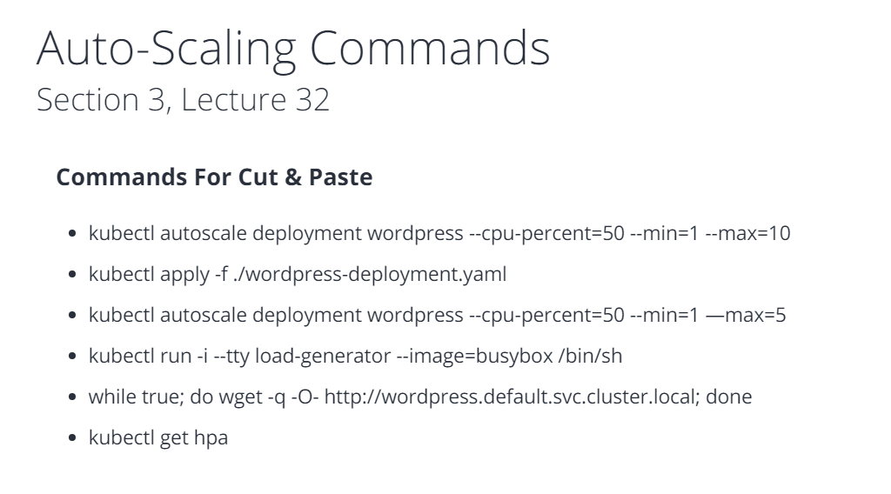

**Auditing**:

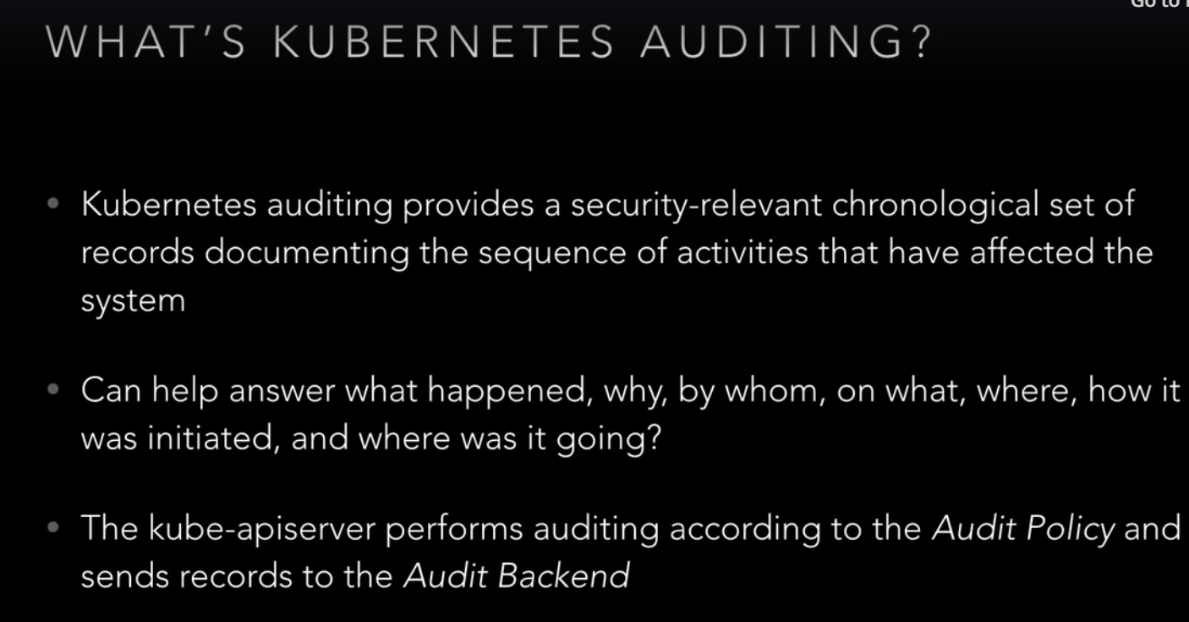

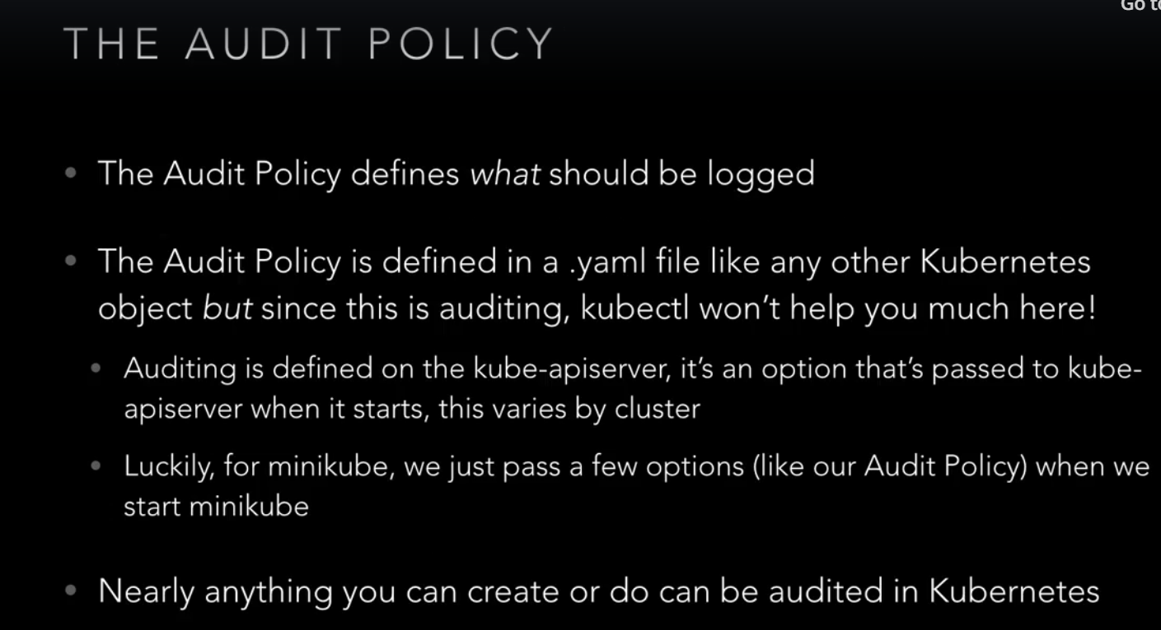

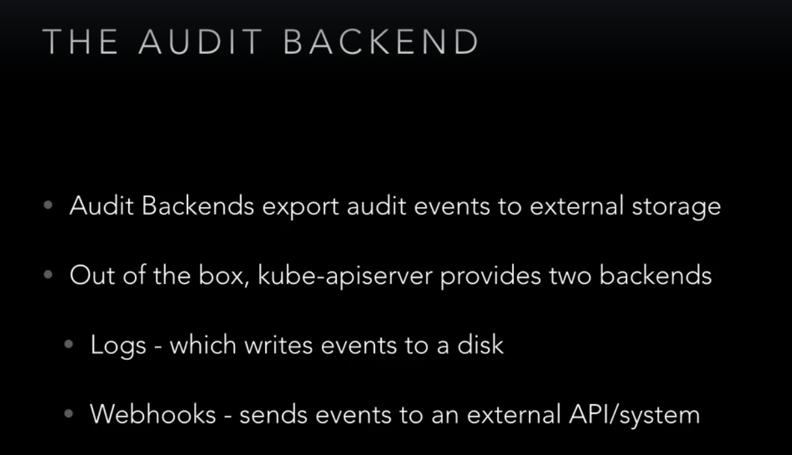

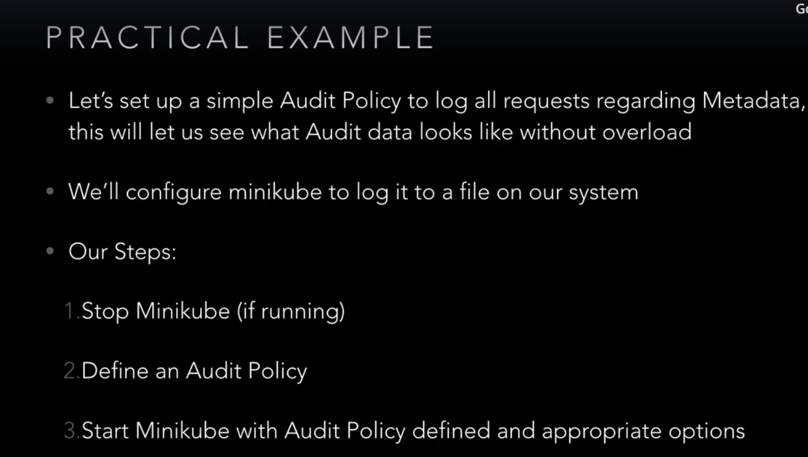

**High Availability**:

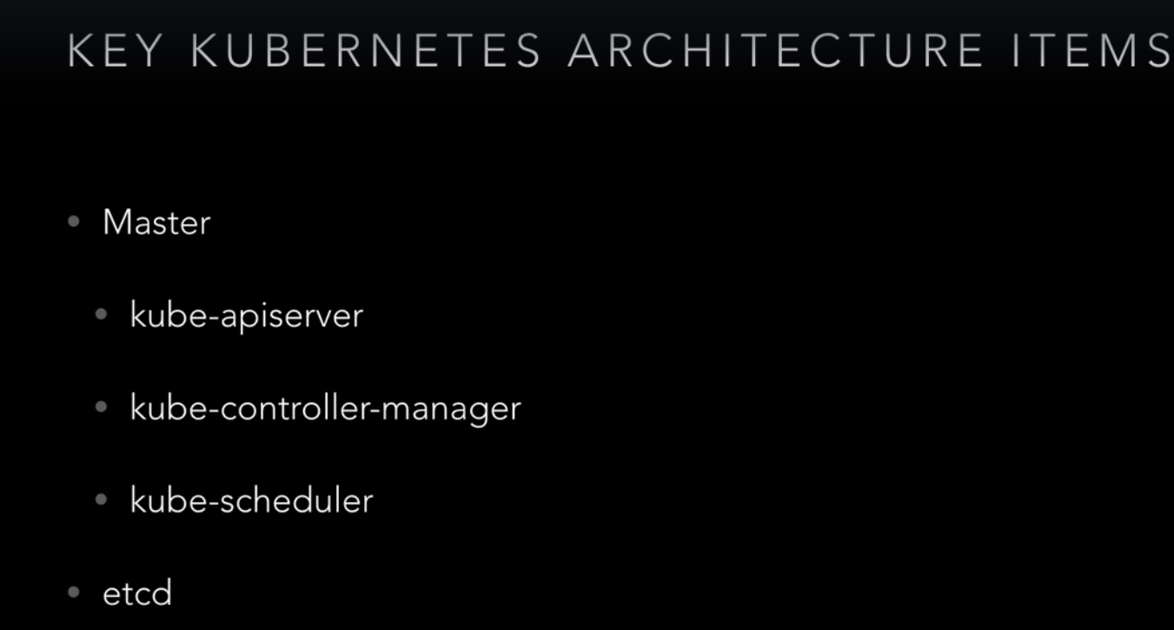

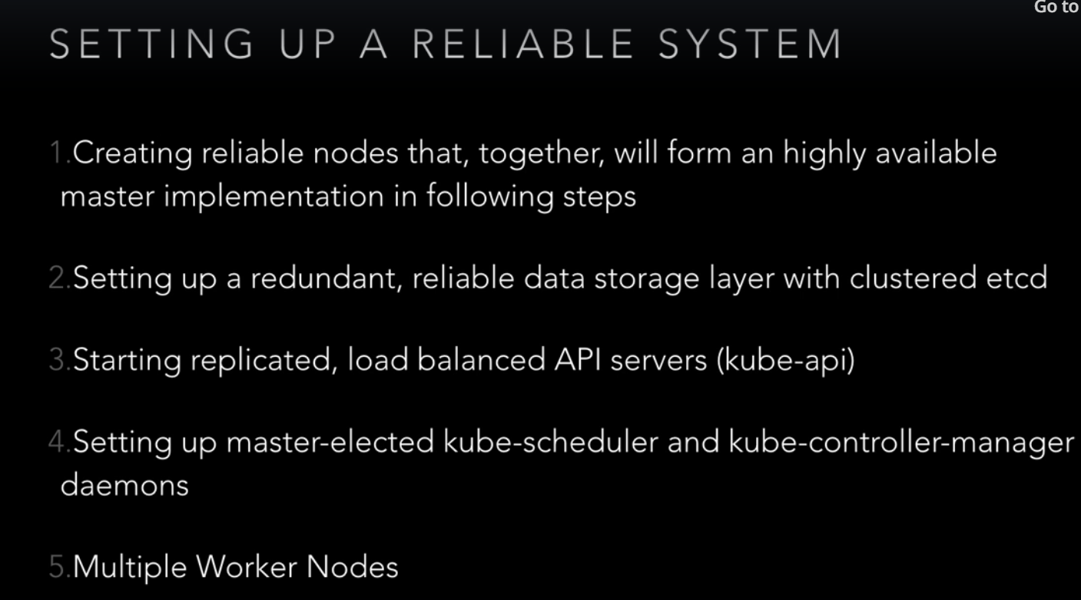

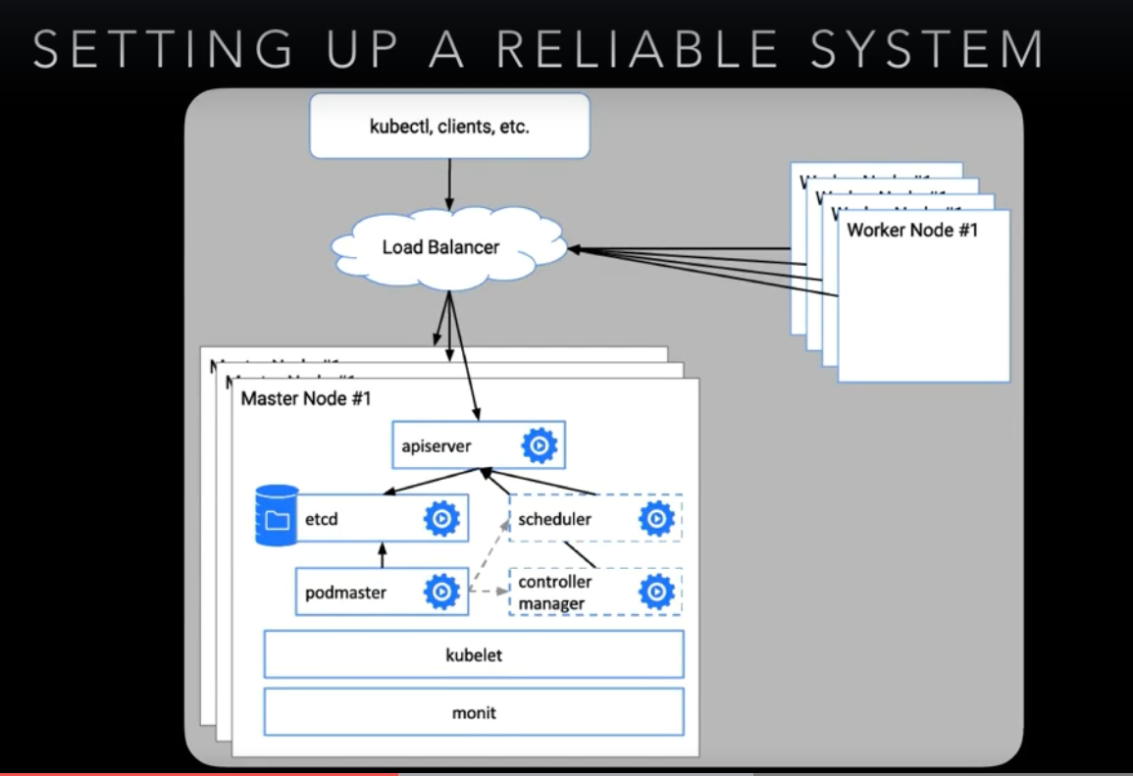

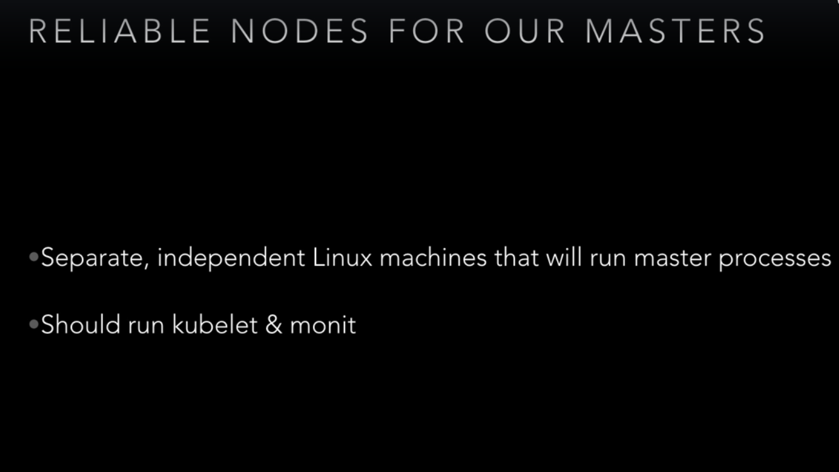

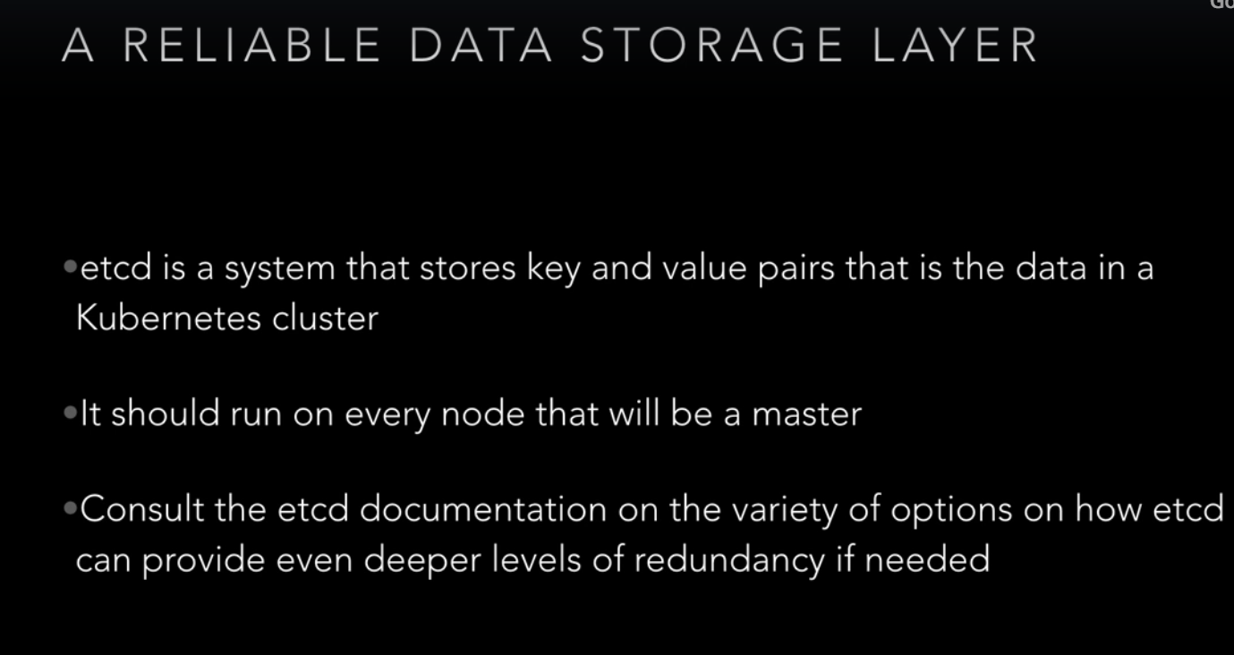

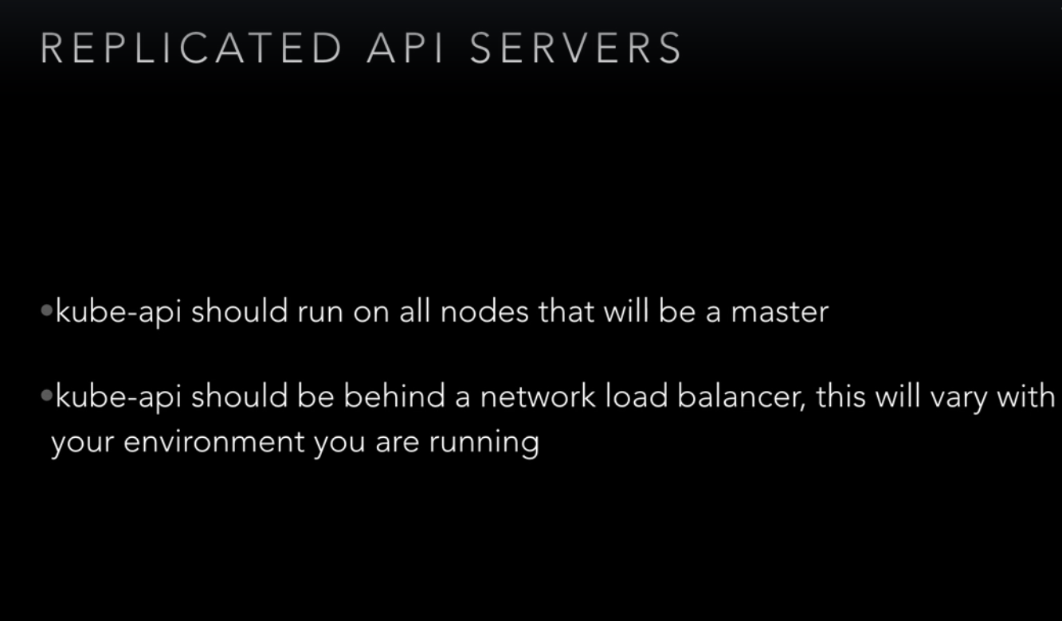

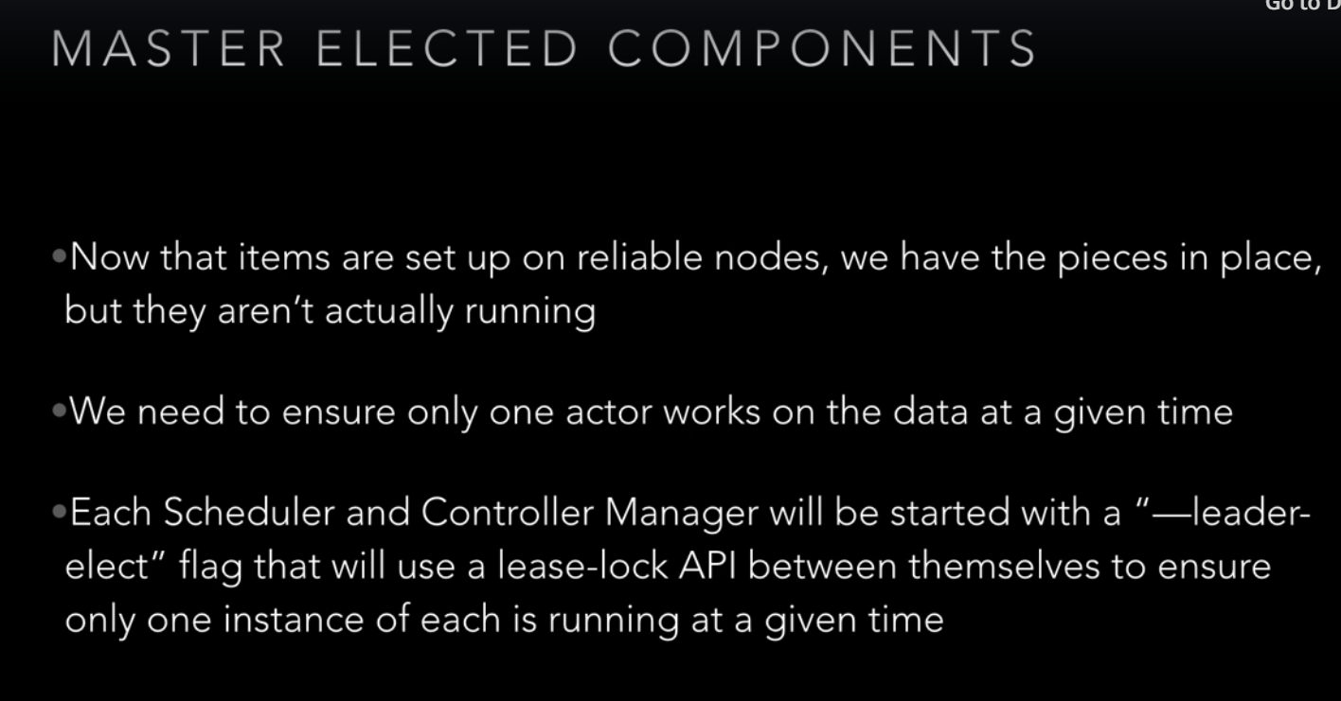

**Masters**:

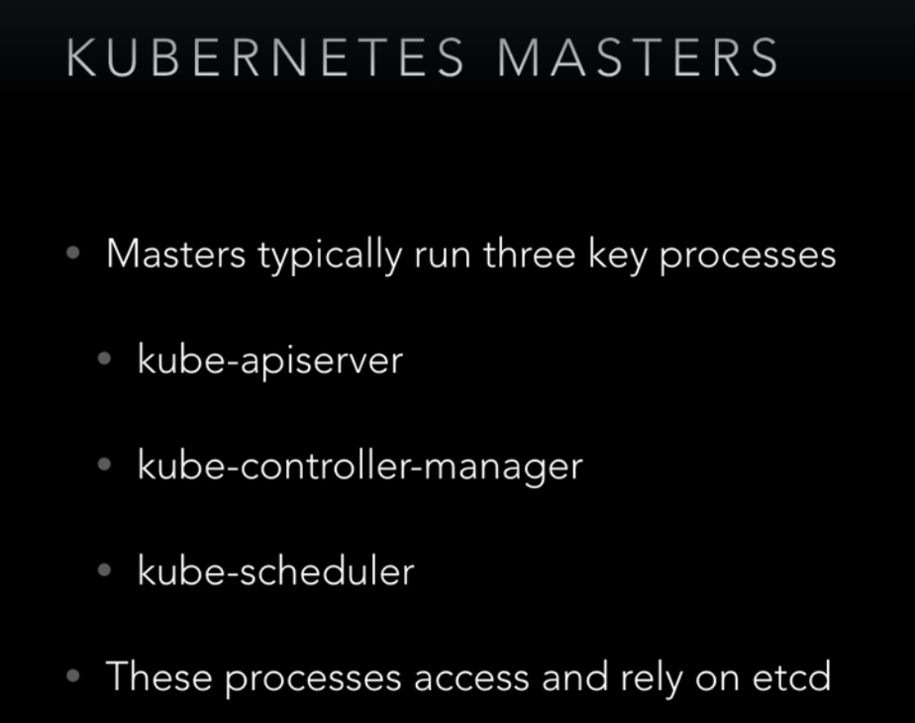

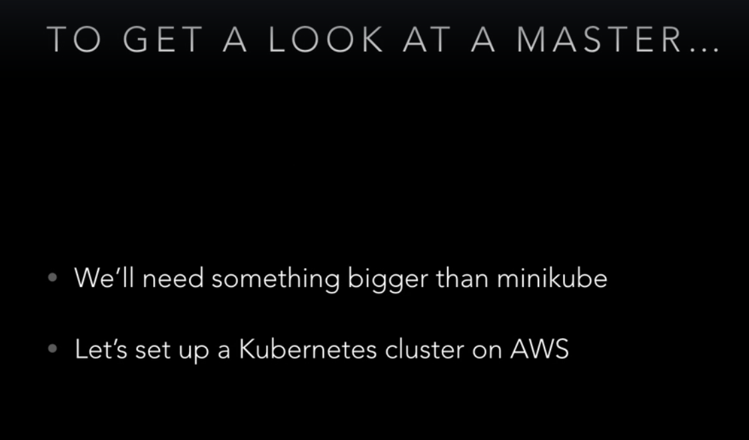

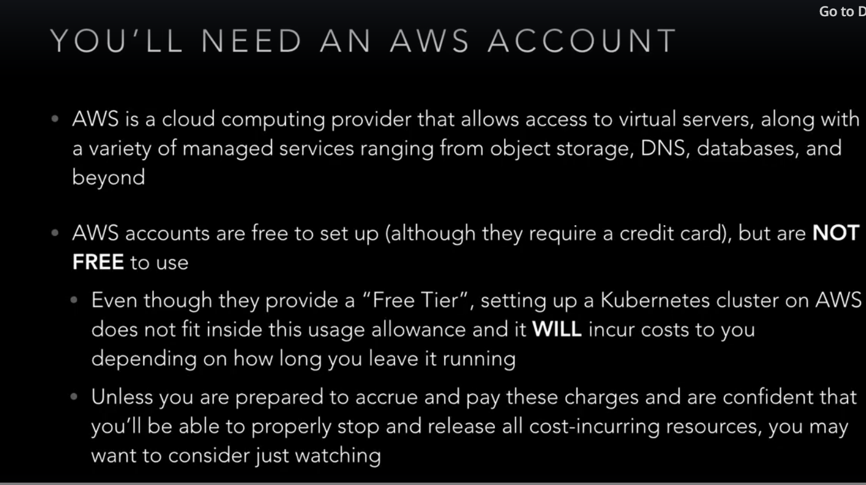

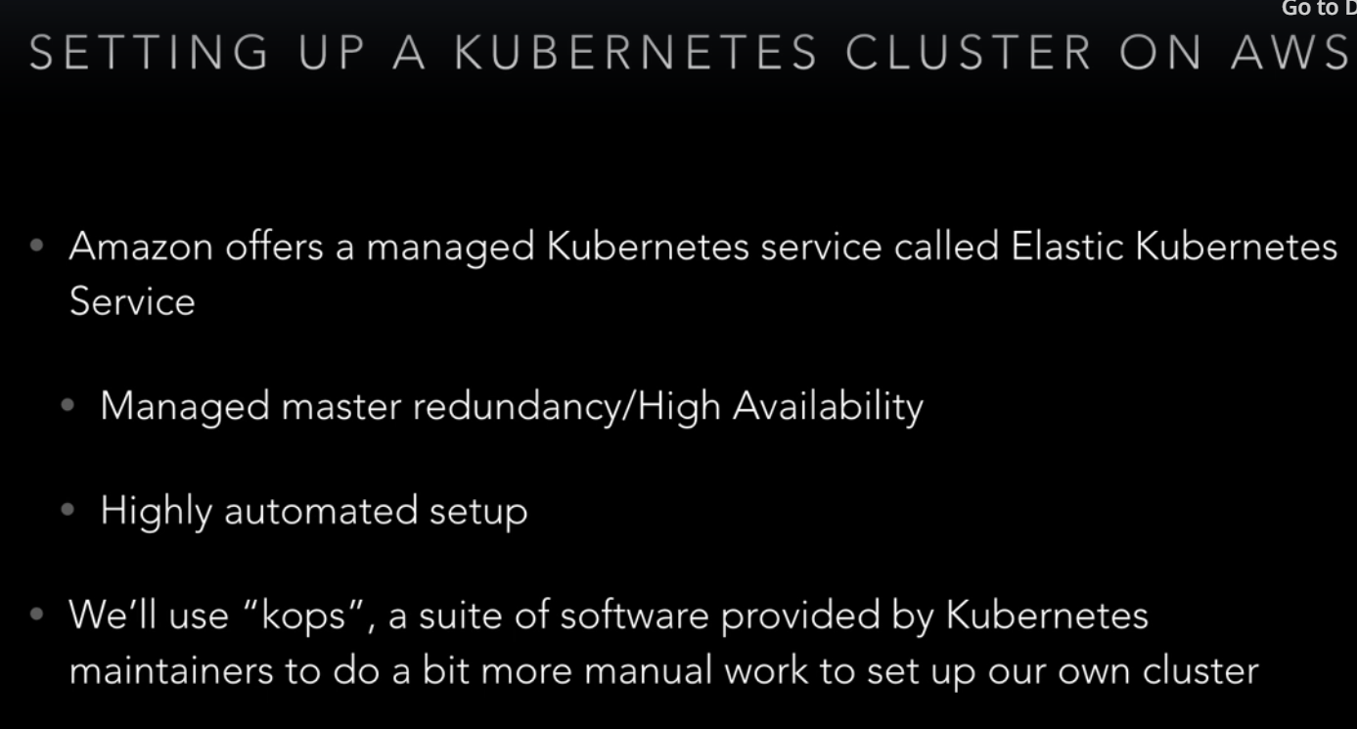

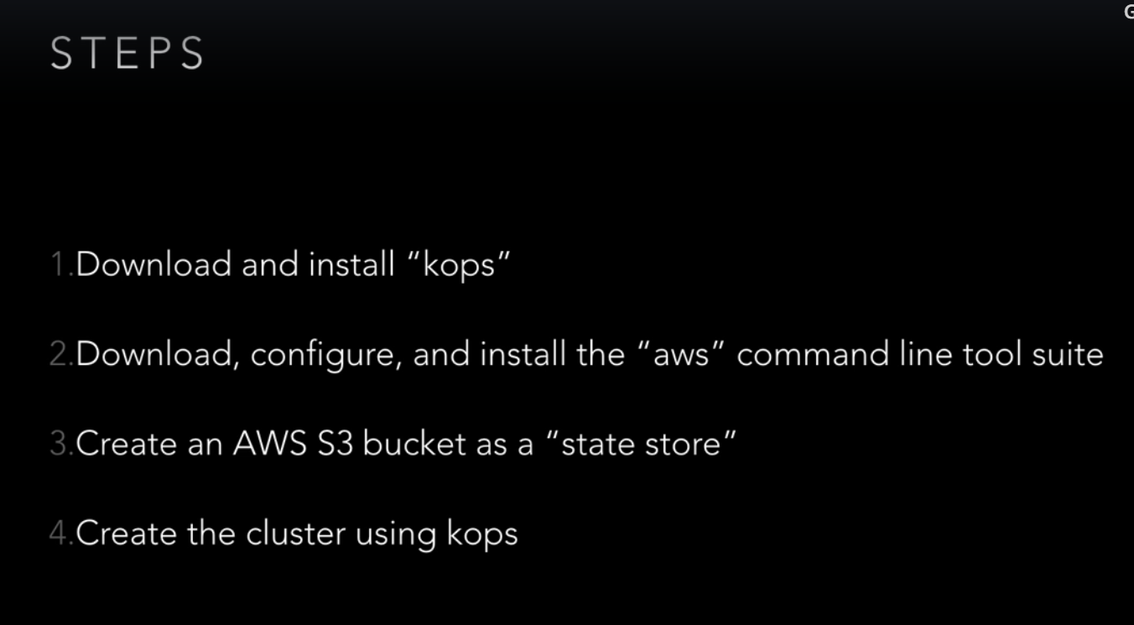

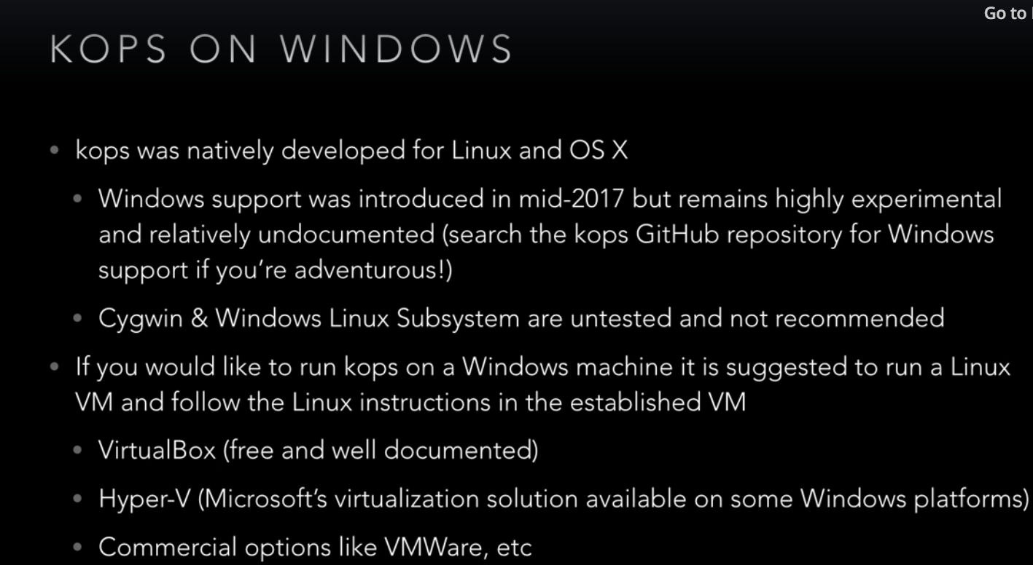

Span a local linux VM using virtual box ans install kubectl and kops using below link.

<https://github.com/kubernetes/kops>

install python – yum install python -y

install pip:

<https://pip.pypa.io/en/latest/installing/>

install awscli using – pip install awscli

Create an s3 bucket to store state of the cluster

aws s3api create-bucket --bucket rev-kops-study --region ap-south-1 --create-bucket-configuration LocationConstraint=ap-south-1

Create cluster using kops

Kops will store cluster state information in a bucket passed to it

export KOPS_STATE_STORE=s3://rev-kops-study

to tell kops to use bucket as state store

kops create cluster rev-kops.k8s.local --zones ap-south-1a –yes(create an ssh key using ssh-keygen before creating cluster)

kops validate cluster

delete the cluster for safer side

**High Availability Cluster**:

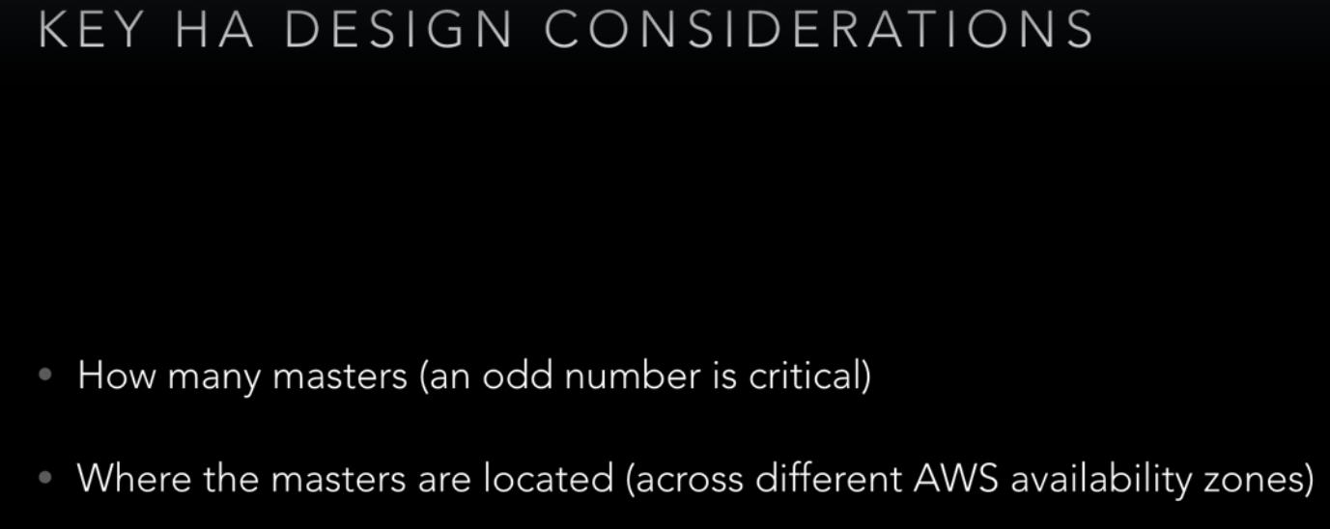

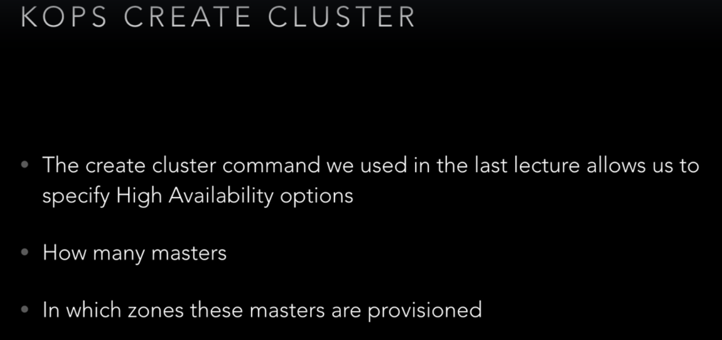

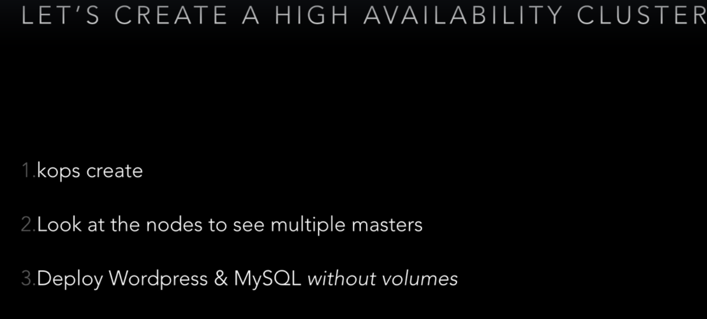

kops create cluster rev-kops.k8s.local --zones ap-south-1a,ap-south-1b,ap-south-1c –node-count 3 –master-zones ap-south-1a,ap-south-1b,ap-south-1c –yes

**Volumes**:

